|  |  |
| --- | --- |
|  |  |



Entra ID, Security, DR, Monitoring

- - - - - - - - - - - -

**Part 3 of 5**

**Contents**

Identity Management – Azure AD ( ENTRA ) 3

Tenant 4

Users and Groups 10

Azure AD Licenses 23

## Identity Management – Azure AD ( ENTRA )

Microsoft changed the name of Azure AD, the identity management service in Azure, to Microsoft Entra. However, in the industry the name Azure AD is stuck & is still being used, & therefore we will use the names Azure AD & Microsoft Entra interchangeably.

|  |  |
| --- | --- |
| It stands for Azure Active Directory and Azure Active Directory is a central identity and access management cloud service and it is used to manage access to thousands of apps. Among them is the Azure portal, there are also other resources inside Azure, including our own app.  It is a secure, robust, and highly intelligent access management service and has a lot of advanced features such as MFA or multi-factor authentication, conditional access device management, hybrid identity, identity protection, monitoring and reports, and lots more. | Azure AD   * Short for Azure Active Directory * Central identity & access management cloud service * Used to manage access to thousands of apps * Among them – the Azure Portal * Secure, robust, intelligent |

|  |  |
| --- | --- |
| Advanced features:   * MFA * Conditional Access * Device management * Hybrid identity * Identity protection * Monitoring and reports * And lots more…   We’re interested mainly in:   * Control access to Azure resources * By setting up users, groups, roles * Not entirely architecture- and dev- related, but still important * Use Azure AD to add authentication to our apps * Can be done also via Azure AD B2C   Azure AD   * Integrates with more than 2,800 apps * Manages more than 1.2 billion identities * Processes over 8 billion authentications every day * Secured using 3,500 security experts in Microsoft * . . . which invests more than $1bn annually on cybersecurity * Largest identity & access management service in the world | Now, we are not going to discuss each and every one of these features but we will touch some of them, especially the MFA. Now, from our own point of view, we are interested mainly in controlling access to Azure resources and this is done by setting up users, groups and roles. And of course, we'll discuss each one of these concepts later.  And note that this topic is not entirely architecture and dev-related, but it's still extremely important because when designing your cloud architecture, you must take into account the authorization and authentication aspect and Azure AD is one of the best candidates for implementing that.  So beside controlling access to the Azure resources that we've created, we are going to use Azure active directory out authentication to our own app to the Read It website because this is another important feature of Azure AD. you can add it to your own app, to the code that you actually write. And this is only one of the things that makes Azure AD so compelling.  Note that adding authentication to our own apps can be done also using a mechanism called Azure AD B2C, which we'll discuss later in this section. So, let's look at some figures of Azure AD. So Azure AD integrates with more than 2,800 apps which is quite a lot. It manages more than 1.2 billion identities worldwide and processes over 8 billion authentications each and every day.  It is secured by 3,500 security experts in Microsoft, which invest more than $1 billion annually on cybersecurity. So Microsoft takes security authentication and authorization quite seriously, as you can see. And all these figures makes Azure AD the largest identity and access management service in the world. |

### Tenant

Before talking about the capabilities of Azure AD, there is one concept that we need to be familiar with and that is the **tenant**. A **tenant** is a **specific instance of Azure AD containing accounts** and **groups**. It is also called **Directory**, and you will see both concepts used interchangeably throughout this course and with Azure. Now, the important thing to note about tenant is that it is not part of the subscription hierarchy. It exists besides the subscription and also for new subscriptions, a new tenant is created automatically which also what happened in our case, in the subscriptions that we created for this course as we will see in just a minute.

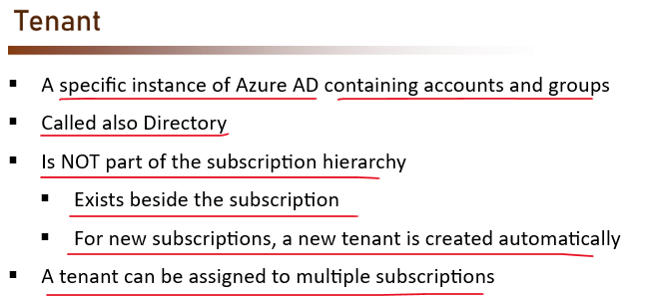

But note that a tenant can be assigned to multiple subscriptions, so you can connect the tenants that we just created to multiple Azure subscriptions if you want the same users to be able to use multiple subscriptions. So you can think of tenant and subscription like this.

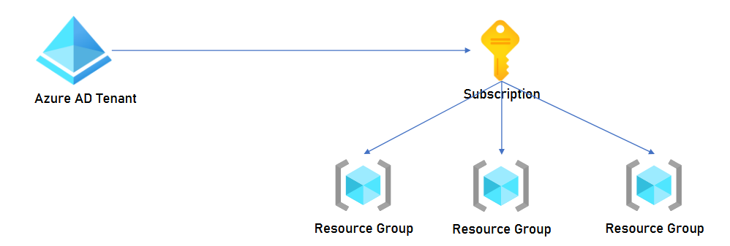

So at the right we have the subscription with the resource groups inside it, and at the left we have the Azure AD tenant which connects to this subscription. So you see that the tenant is not part of the subscription hierarchy and basically it's not an Azure resource because, as we said before, Azure Active Directory is basically an external resource that can connect to many apps and one of them is Azure.

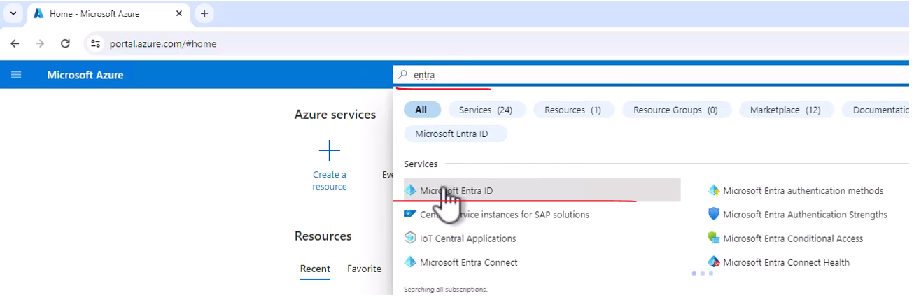

Let's go to our Microsoft Entra, or Azure Active Directory as it was used to be called. So here in the search bar type Entra, and click Microsoft Entra ID. And here is our Entra ID or Azure Active Directory. Now the first thing I want you to look at is the name of this directory, which is Default Directory, and you can see it also here, Default Directory.

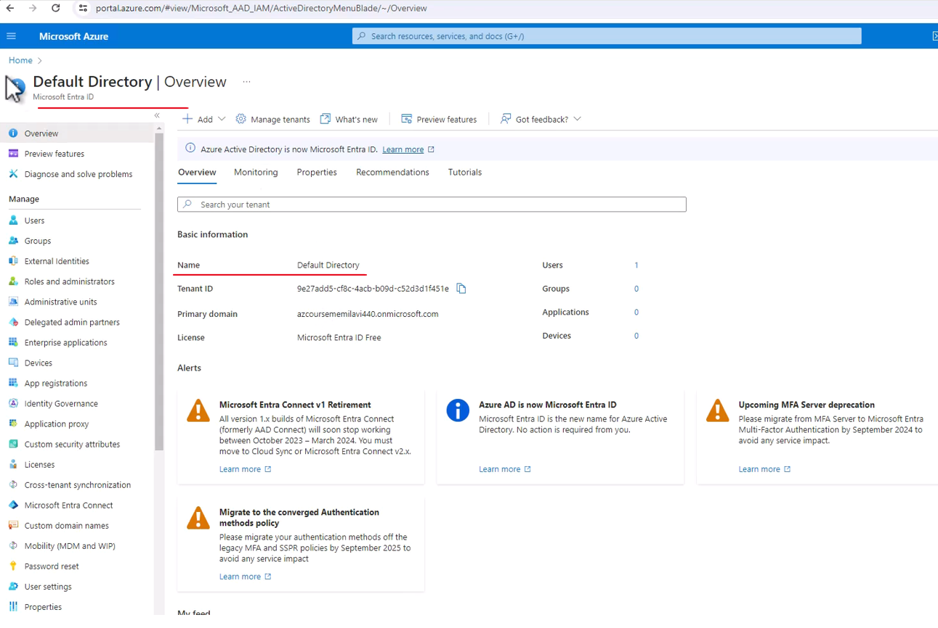

Now, this name actually appears also under the account name that we are using. So it might look familiar to you, and that's not a coincidence because if you take a look right here, so here you can see your account name, and underneath it you will see Default Directory. And this Default Directory is this Default Directory, this is a default name that is given to the tenant that we create. So let's see how to change that.

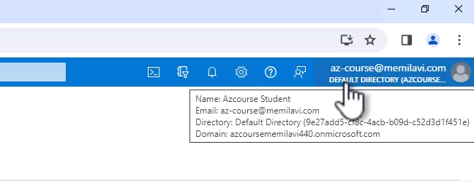

So in the menu on the left click properties, and here we can change the name of the tenant. So let's do that, instead of Default Directory, type Azure Course Directory, like that, and save.

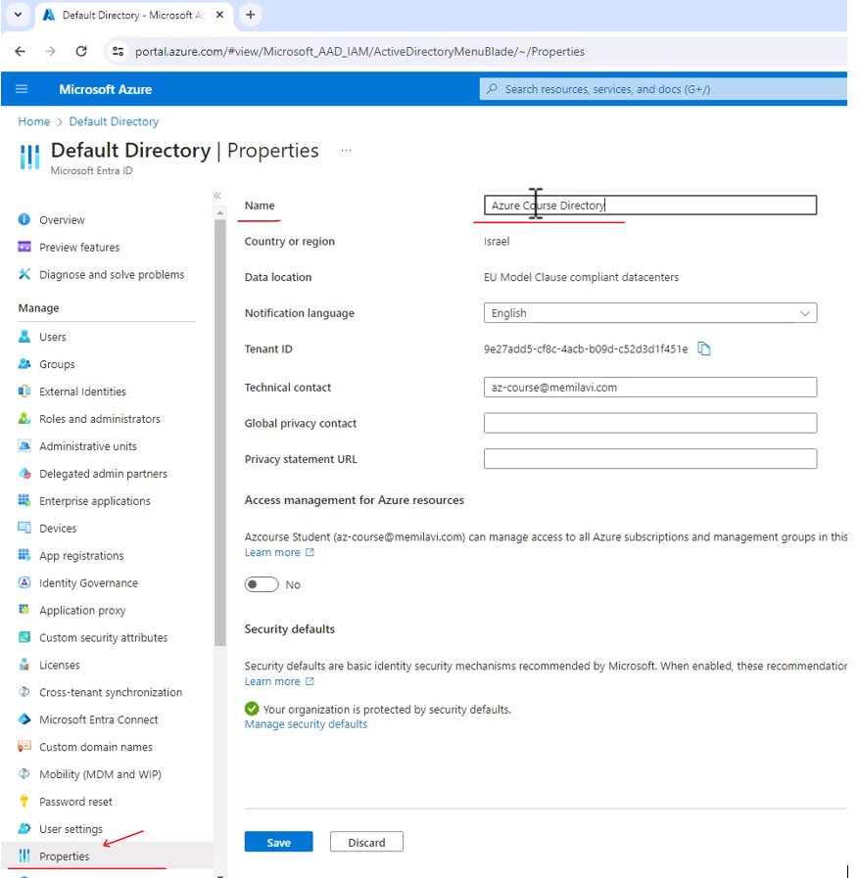

And let's wait for that to complete. Great, and the name was changed successfully.

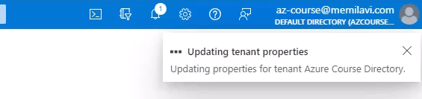

Now you will probably still see here the old name and that's because it takes a few minutes for this change to take effect, but in a few minutes you will see here the new name, the Azure Course Directory.

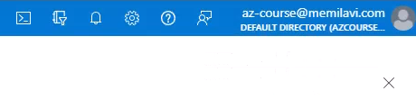

Now let's take a look at the users that are part of this tenant, so click users right here. And unsurprisingly, currently there is only a single user in this tenant. And this user is basically, well, you, and we can see some details about this user.

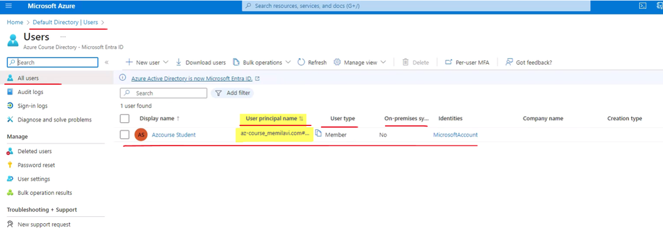

So for example, we see here the user principal name, which is the full name of the user as it is registered in the tenant. We can see the user type, which is member, and member means that the user was created directly inside this tenant. We can see that the user was not synced from an on-premises Active Directory and so on. Now let's click into this user, and here we can see some details about this user. For example, its Object ID, which we might be using later. And we can also see how many roles are assigned to this user.

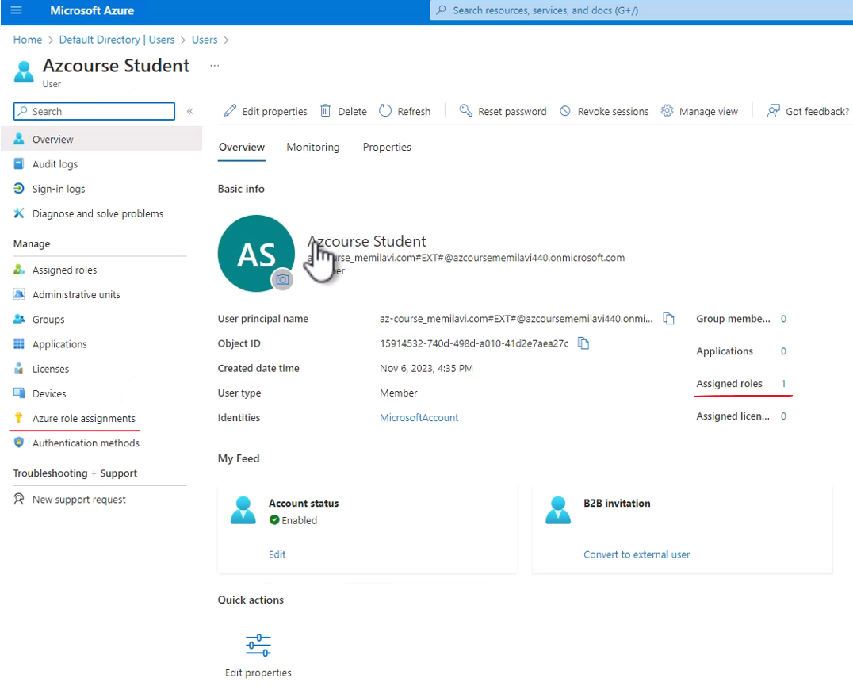

And currently the number is one, meaning there is one role that is assigned to this user, and let's take a look at this role and notice that you can access it either by clicking this number or through this menu item. So let's click that. And here is the role that is assigned to our user and the role is Global Administrator. And Global Administrator is the most powerful role in Azure AD or in Entra. And basically it means that you can do everything inside this tenant.

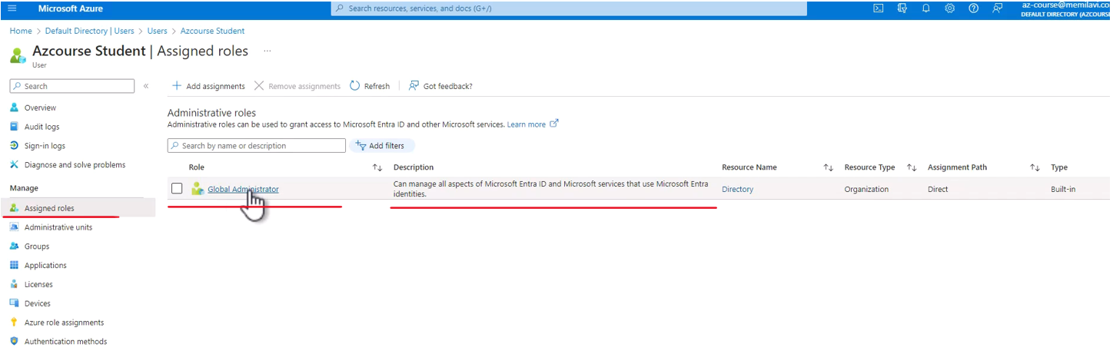

And this is usually the role that is assigned to the user who created this tenant. And we'll talk quite a lot about roles later in this section. Now, one more thing I want to show you about users in Azure AD is the sign-in logs. So click here and here we can see the list of recent sign-ins that we did to this tenant.

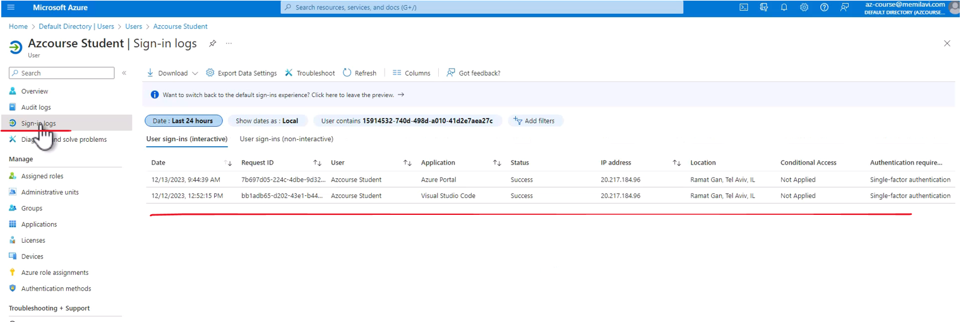

And notice that by default, we see the list for the last 24 hours. Let's expand this to say seven days and apply. And let's wait for that to load. And here is the updated list, naturally it is much longer. Now note the authentication requirement here, this column, and basically this column tells us how we sign in into the tenant.

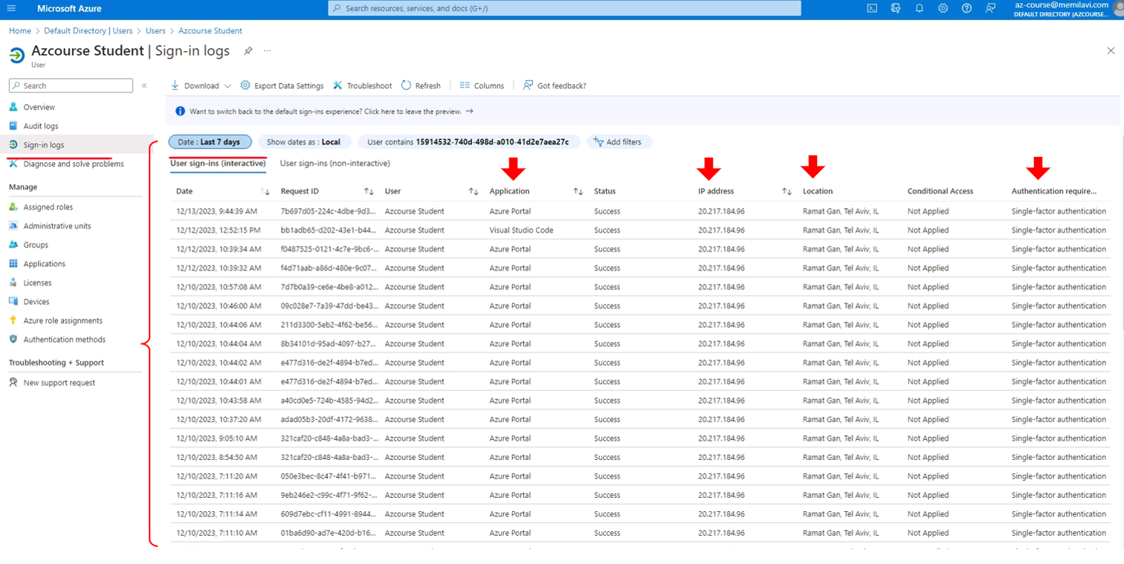

And note that currently all our sign-ins are single factor authentication, which is the weakest sign in possible because we need to provide only a single data, which is of course the password, in order to sign in. And we'll see later how to configure it to be more secure. Now let's close this page and go back to the user's menu and note the password reset here. So click that and here we can configure self-service password reset, meaning the users that are registered inside this tenant can reset their own password.

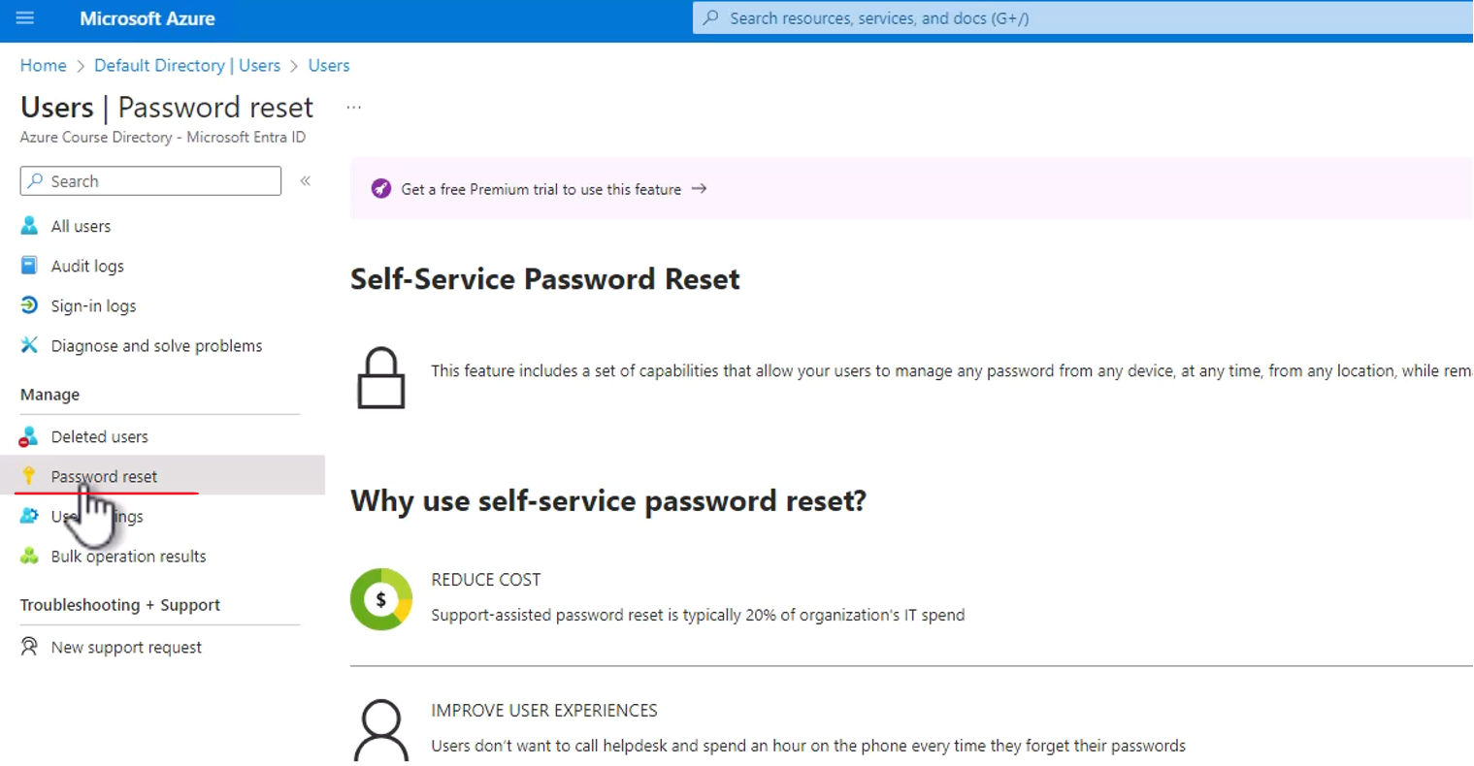

So if they forgot their password, they won't need to pick a phone or write an email to you or to any other system administrator, but they will be able to do it all by themselves. However, this feature is currently not available for us because we are using the free tier of the Azure Active Directory. And in order to take advantage of this feature, we need to upgrade the license and we'll talk licenses later in this section. Now if you remember, we discussed earlier that a single account can be attached to multiple tenants. So how do we switch between the tenants that we are currently using? So for that we have this button labeled directories and subscriptions. And note that we also have this button, the settings button, and actually both the buttons do exactly the same and they will point us to the directories and subscriptions page. So let's click that. And here we see the list of all directories that our account is assigned to. And currently we have only a single one, which is the directory that we are working in right now.

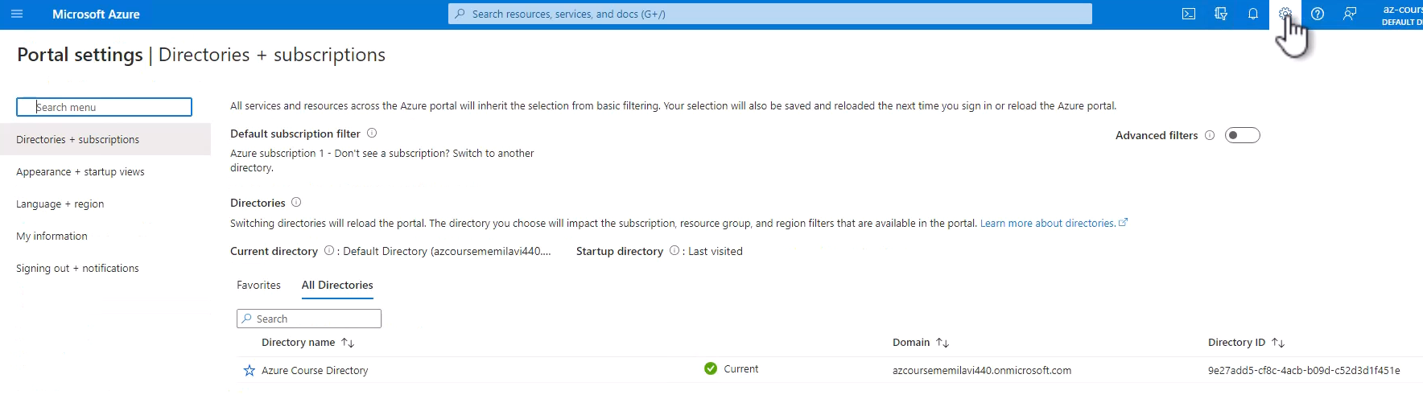

However, in the future, when your account will be part of other tenants, then you will see here a list of tenants and you will be able to switch between them by clicking a switch button that you will see right here. So this is how you switch between tenants, and this was our first look on Azure Active Directory or Microsoft Entra.

### Users and Groups

Let's talk about users and groups, which are two of the main three objects managed by Azure AD. The third one is, of course, roles, which we will talk about later in this section. So using users and groups, Azure AD managers and stores the users that are part of the tenant, and also, it can use groups, which will group the users in groups. For example, we can define groups named IT Admins or Developers, et cetera, which will hold the users that belongs to this logical group. Now, using groups, we can define roles to the group itself instead of each user, which makes the role definition much easier.

**Users** and **Groups**

* **Two of the main three objects** managed by Azure AD
* The **3rd one is Roles** (later…)
* **Manages and stores the users** that are part of the tenant
* **Groups** the **users** in Groups
* Examples: **IT Admins, Developers**, etc.
* Allows defining **roles to groups instead of each user**

Let's go to Microsoft Entra ID that we already saw before. And in order to create a new user, let's go to users here and click new user and create new user.

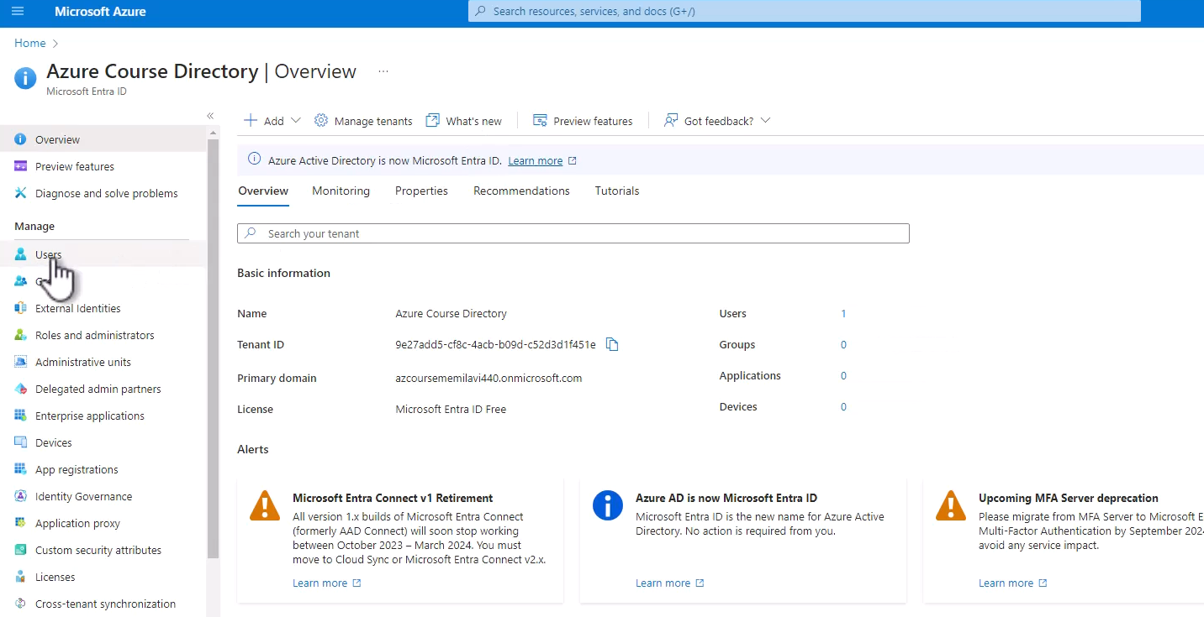

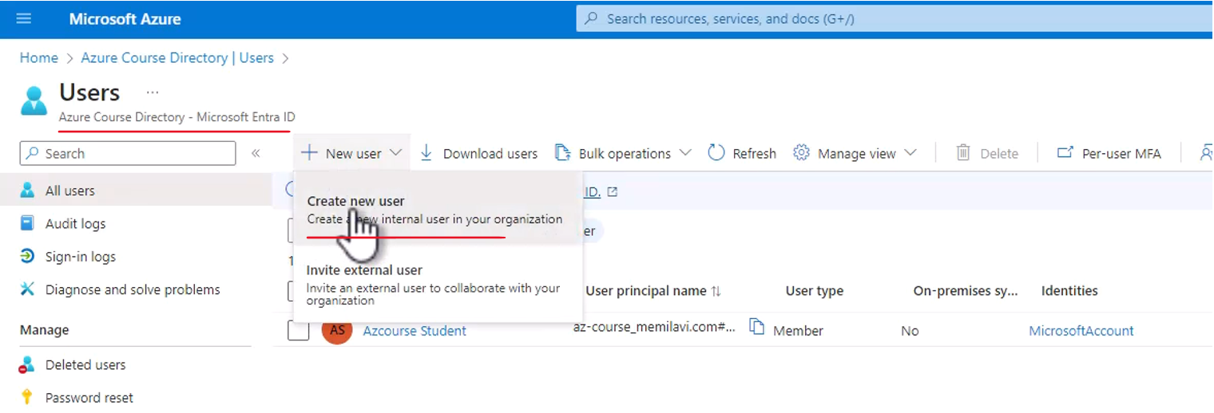

So now we are going to create the new user and let's name this user David. So this is the way David will log in. This is his username david@ and the domain that appeals here, this is quite long domain. And note that anytime you create a new tenant, this tenant is assigned a new domain and the domain is always in this form. So first, we have the <name of the tenant> and then <dot>.microsoft.com. So again, wherever you create a new tenant, expect to see a domain like that. Great. So that is going to be the username of David. And let's set the display name to be David Jones. And now, Azure generated a password for David Jones. We can of course generate our own, but let's use the one that was generated by Azure and let's copy this password because we are going to use it later.

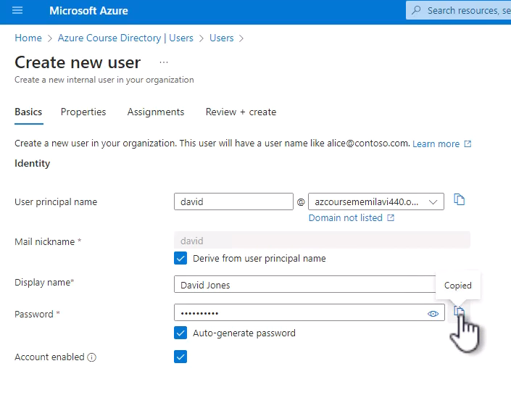

Now, these are the base details of the user and let's take a look at some more advanced properties. So navigate to the properties tab right here. And you can see here multiple fields that you can fill-in in order to provide some more details about David.

|  |  |
| --- | --- |
|  |  |
|  |  |

|  |  |
| --- | --- |
| So for example, we can fill in his job title, company name, of course, first name, last name, and a lot of other details. We are not going to deal with it right now. And let's move on to the assignment tab. And here, we can assign groups and roles to David.  So we are not going to do it right now, however we will discuss that later in this section. So, that's basically it. So let's review plus create. And here are the details of David. Now in order to sign-in, we will need to have the user principle name, which is basically the username and also the password.  So let's put those two in a text editor. So, I will use Notepad here. So, let's open it. And this is the password, this is a temporary one.  And let's also copy the username and copy it right here. And let's create the user. And here is the new user, David Jones. Great. Now let's see how to use the sign-in details of David Jones to sign-in into the portal. |  |

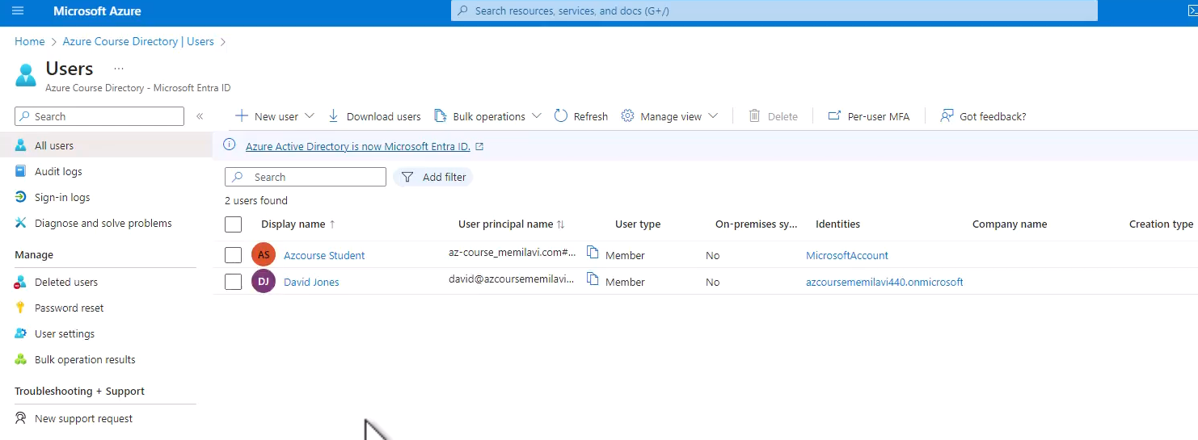

So go to Incognito mode in your browser. So this is usually done using control, shift, and N. And now, we are in Incognito mode. And you can also see that right here. And the reason we are doing that is because we don't want to use existing sign-in, which is basically based on your account, but we want to sign-in using David Jones details. So in the incognito page, go to the Azure portal, and now, let's sign-in. So let's copy this username and place it here.

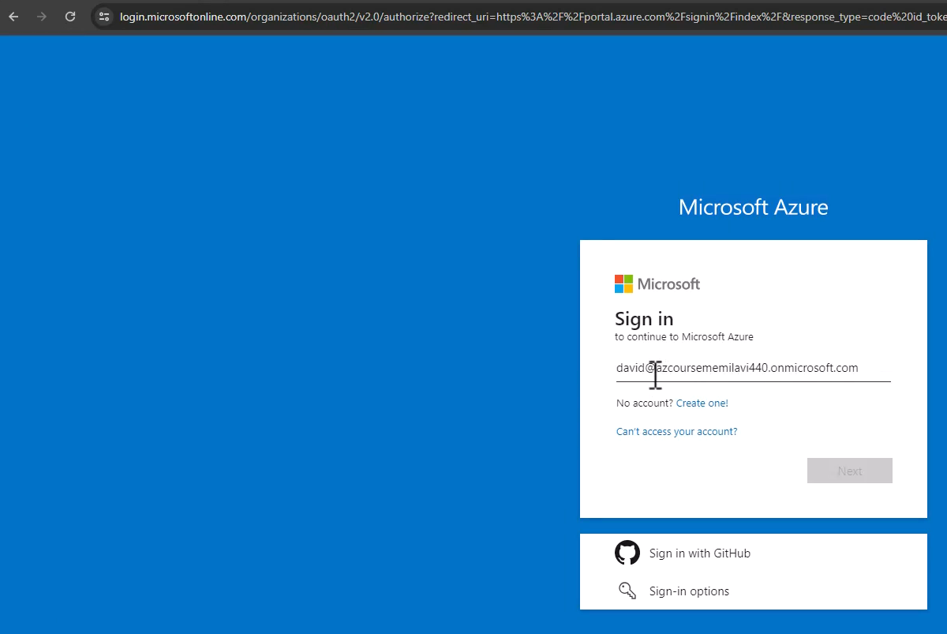

And now with the password. So copy that. And again, this is a temporary password and paste it here and sign-in.

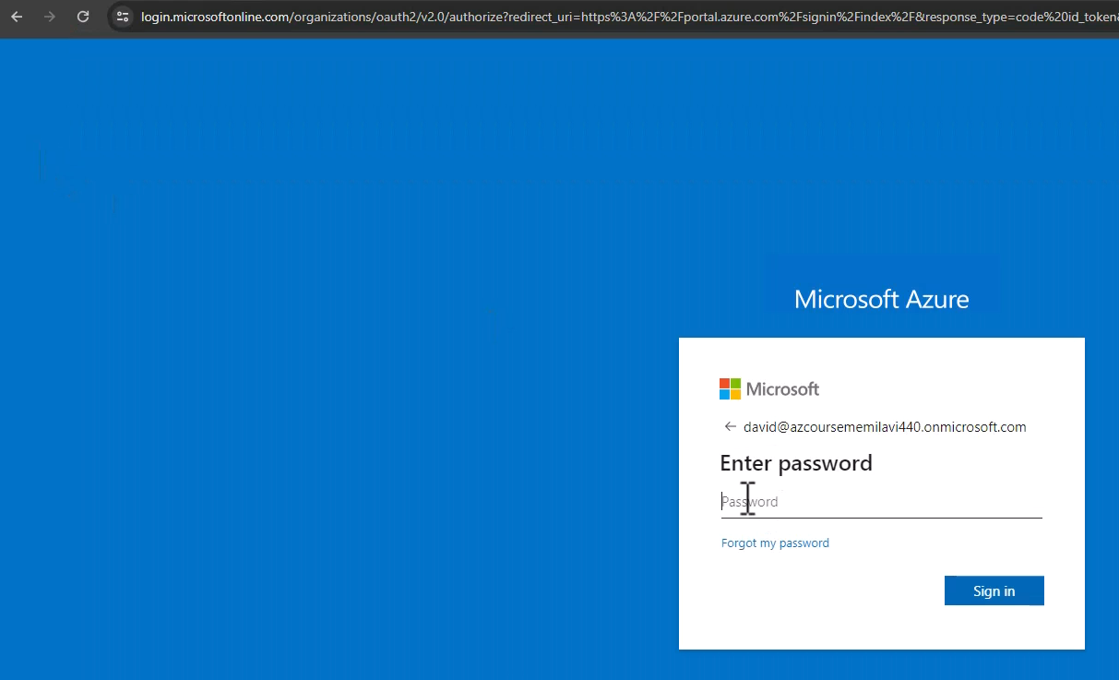 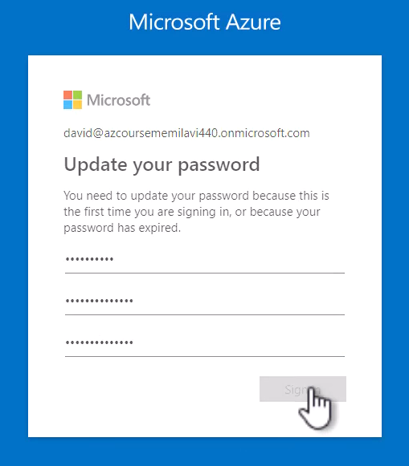

And now, we need to update our password. So paste here the current password and select a new one. So I will do that and let's confirm this password. Great. And sign-in and let's pick another password. And if you get this message, then simply click ask later. Okay.

|  |  |  |
| --- | --- | --- |
|  |  |  |

And yes, stay signed in. So yes. And now, we are in Azure portal. Let's click maybe later. And this looks exactly like the portal that we are working with. However, there is one important difference. And note the message right here, don't have a subscription. Check out the following options. So it looks like David Jones can sign into the portal. However, the account is not attached to any Azure subscription and therefore, if you will try to create a resource, for example, let's go to storage accounts, then we'll see this message again.

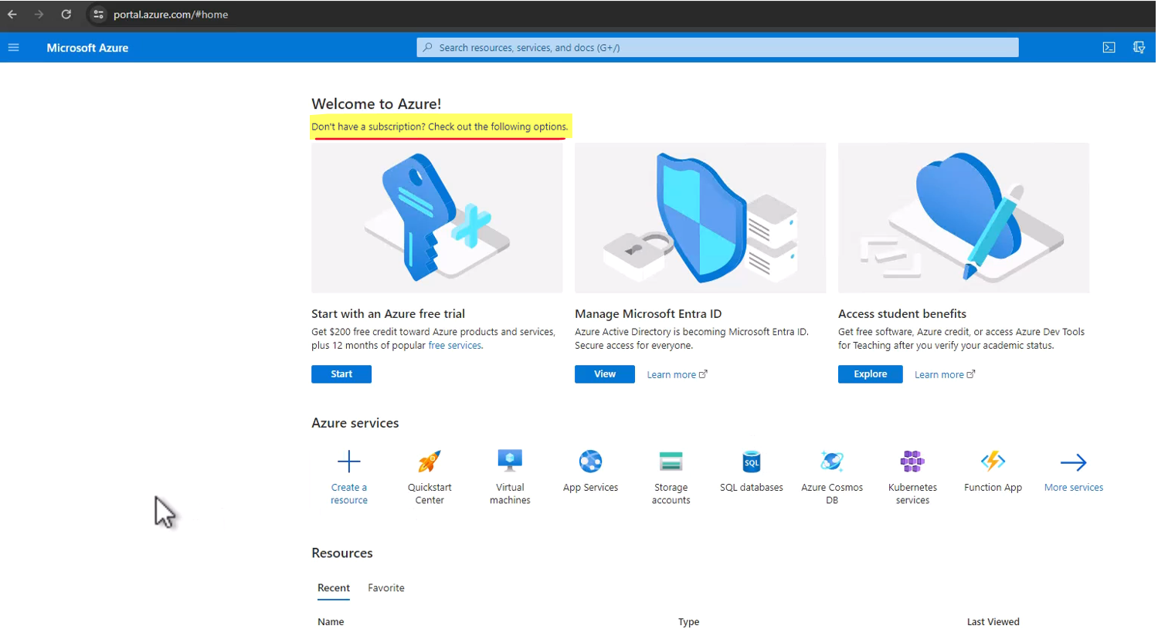

So we cannot create new resources as David Jones. And why is that? Well, this is because we created a new user in Azure AD or in Entra, but we did not authorize this user for a specific Azure subscription and therefore, Azure has no ID.

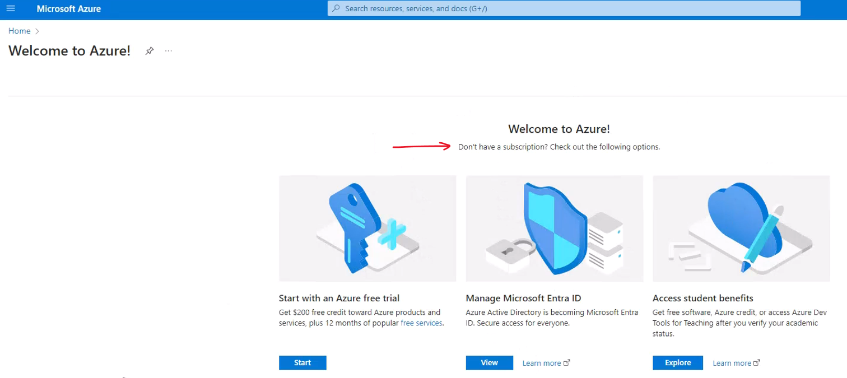

What is the subscription that we want to work with? And in order to do that, we need to add permissions or roll to David Jones in the Azure subscription that he should be able to work with. And we are not going to do that now, but we will do that later in this section. So anyway, we see that David Jones can sign into the Azure portal using the details that we provided and that's good enough for us right now. So let's close the incognito page and let's go back to this page and now click sign-in logs and note this record. And we can see here that David Jones signed into the portal from this IP address and from this location and so on and so forth.

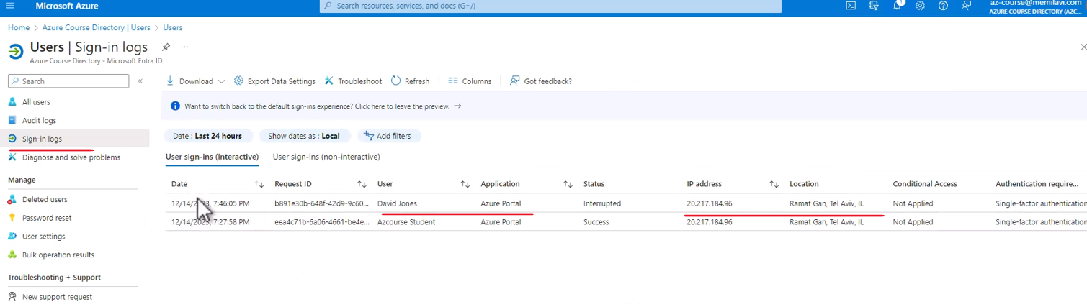

|  |  |
| --- | --- |
| So we can see here how the sign-in logs can help us audit what exactly is happening with our tenant. Great, so we created a new user in Azure AD. However, we can also invite an existing user and this is called guest user.  And guest user is basically someone who already has an email address and we want to invite this user to our tenant and let's see how to do that. So let's go here to all users and again, new user. And this time, click invite external user. |  |

|  |  |
| --- | --- |
| So now, type in an email address that you're using, which is not the email address used for creating the account. So in my case, that would be memi@memilavi.com. Of course, yours will be different. The display name is Memi Lavi and let's add in some personal message. Hi there, you are invited to my Azure ID tenant. Great. And that's it, basically, so review plus invite and invite and invitation is in progress.  And now, an email was sent to the email address that I typed in. And using this email, I will be able to sign-in to the tenant. So let's wait for the email to arrive. And here is the email. So, let's see what we see here. We see that this organization, the Azure course directory and remember that we changed the default name of our tenant to this one. |  |

And this is a domain of this tenant is inviting me to join the tenant and this is a personal message that was sent to me. Now since I'm familiar with the owner of this tenant and I definitely want to join. So, let's copy this URL.

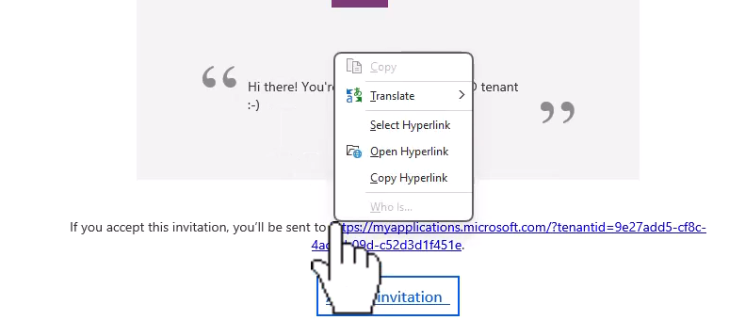

You can also click the accept invitation button and let's go back to our portal. And now, I want to go again to incognito because I don't want to be automatically signed in with the default account. But to use the memi@memilavi.com account. So paste here, the URL and let's sign-in. And again, I need to sign-in using the email that I typed for the invitation.

|  |  |  |
| --- | --- | --- |
|  |  |  |

So, that would be it. And I will sign into my email the same way I always do with other apps. So, I will just handle that in the authenticator app. Yes, I want to stay signed in and now the tenant is asking for permissions to access some of my data. I have no problem with that and therefore, accept. And now I am signed in to the tenant. Now note that here, I should be able to see the list of apps that I'm allowed to access, but the Azure portal is not here.

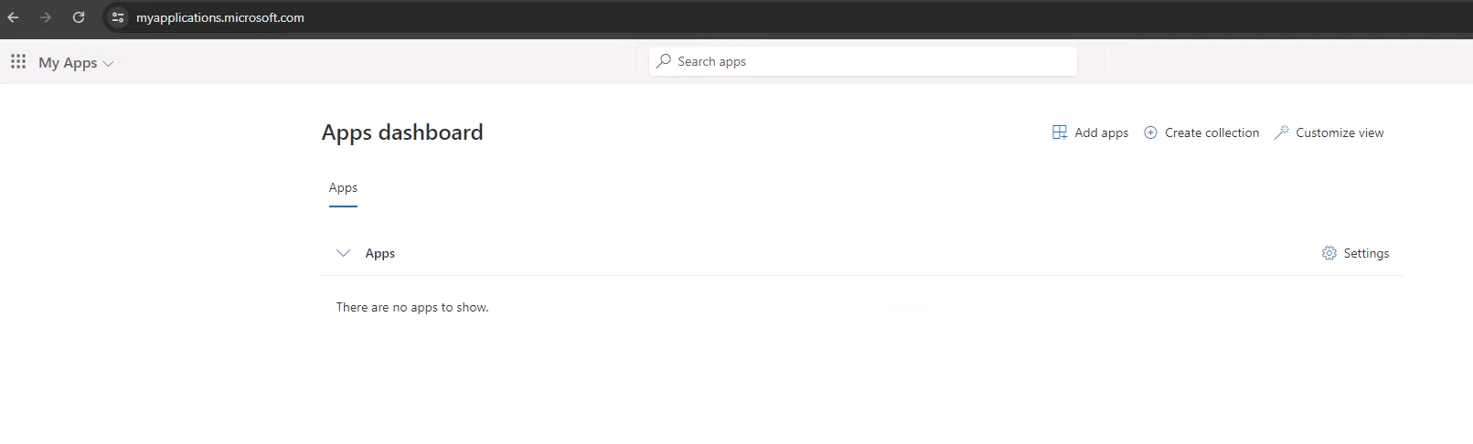

So we will access it manually. So type here the portal URL and here is the portal. And as before, I don't have a subscription that I am have the new email address can access to and therefore, I cannot create resources in Azure.

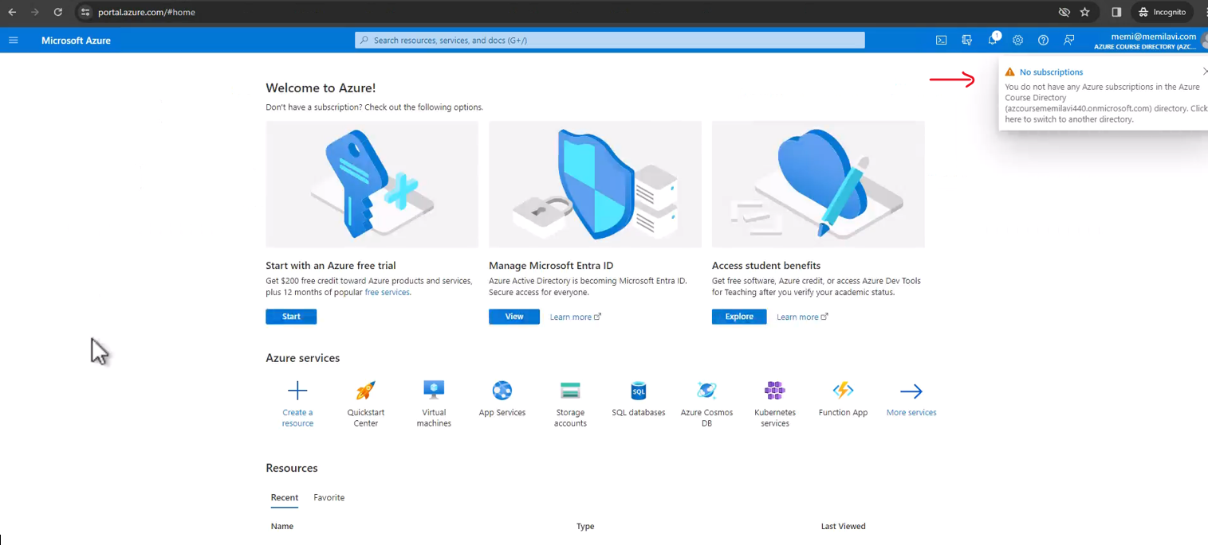

So this is how we work with guest users. So, let's close this. And now, I want to work with groups. So let's close that and let's go here to groups. And I want to create a new group and add a user to it. So click new group.

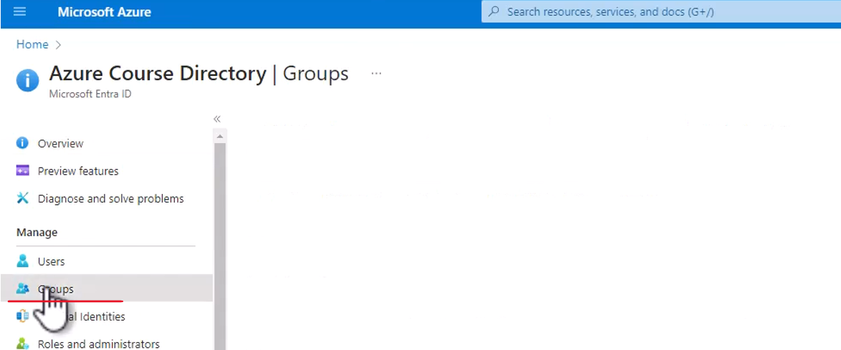

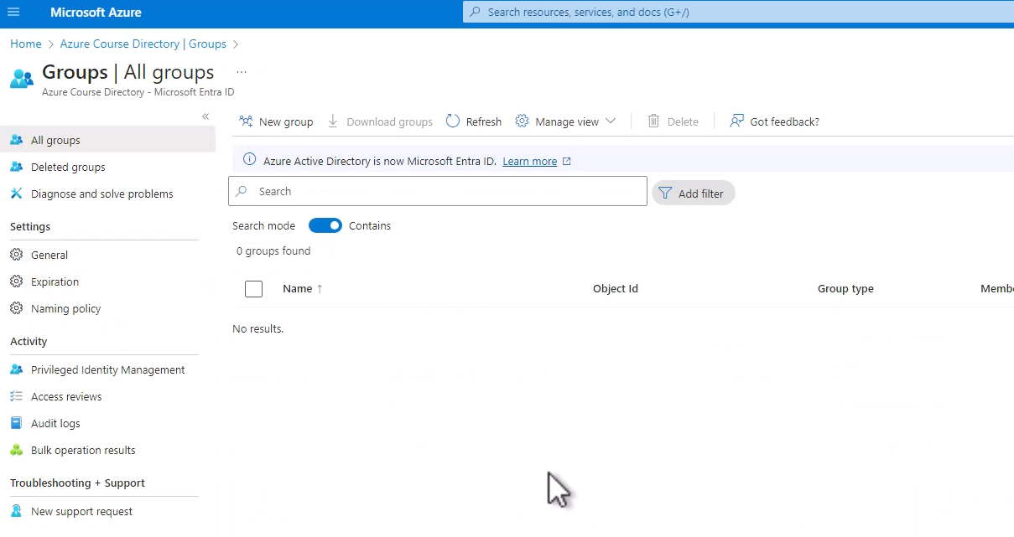



And for the group type, make sure that security is selected. And security is the default group.

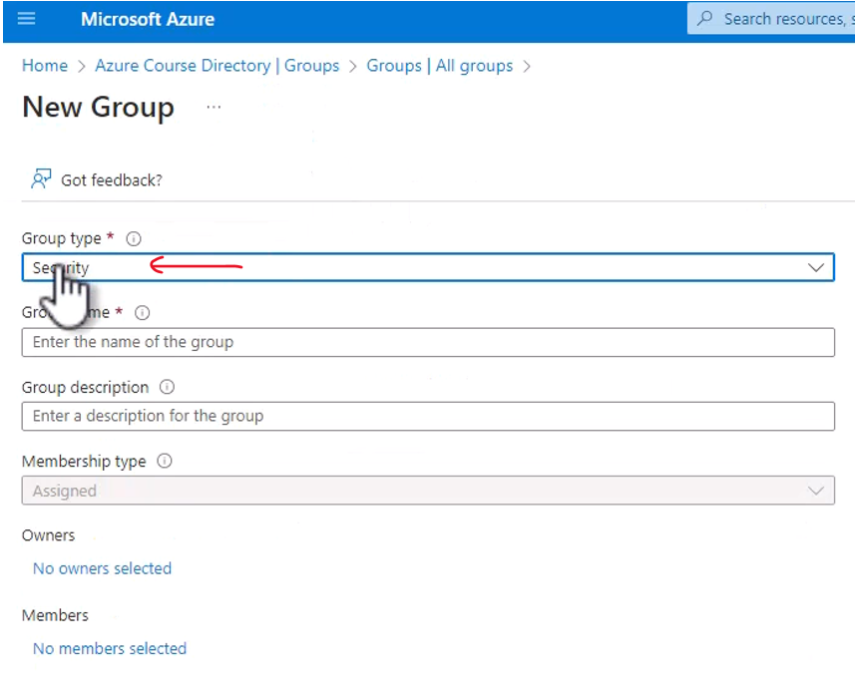

And this is basically a group that is managed by Azure AD and can hold users from our tenants. So we will stick to the default and the group name is going to be Azure Architects like that. And now, let's select members for this group. So click here, the no members selected link, other members. So click that. And I want to add David Jones to this group.

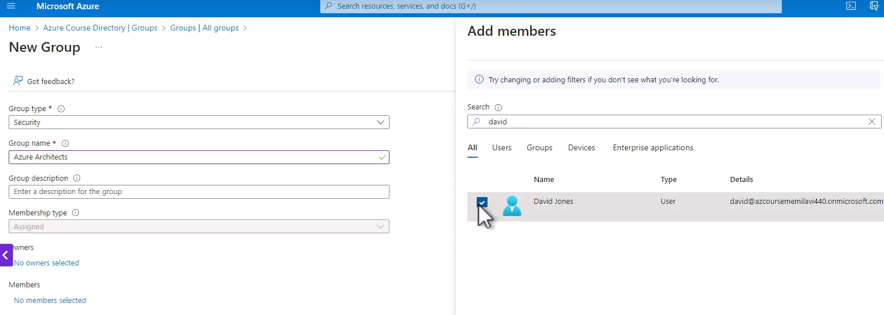

So in the search field, type David. And here is David Jones, check this checkbox and select. And one member was selected. Great. So now create and the group is being created and it was created.

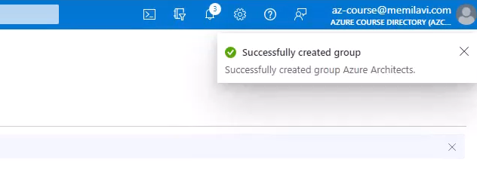

So now, let's hit refresh here to see the group. And here is our group.

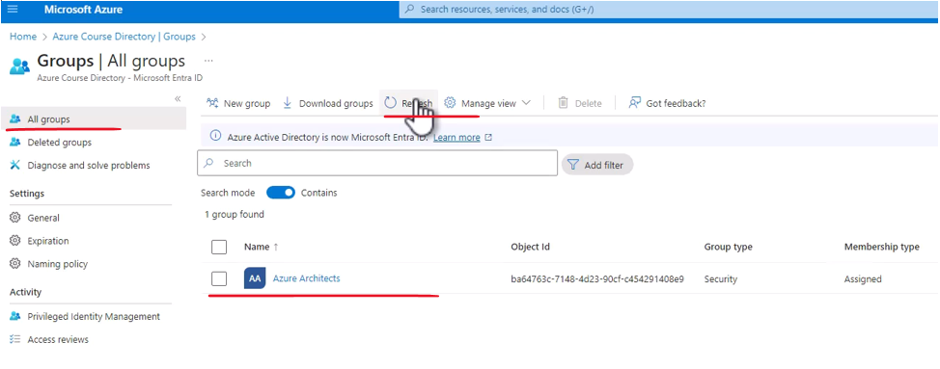

And you can see here the object ID. We'll explain it, what exactly is this object ID and let's go into this group.

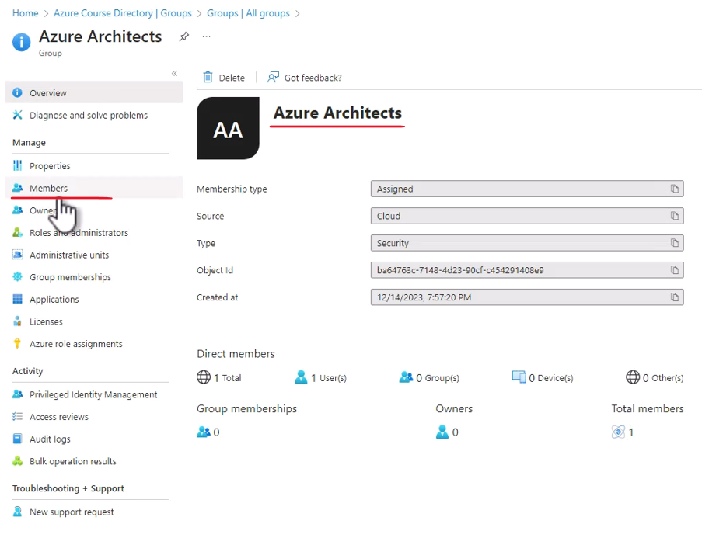

And you can see here, click members that this group has a single member, which is our David Jones.

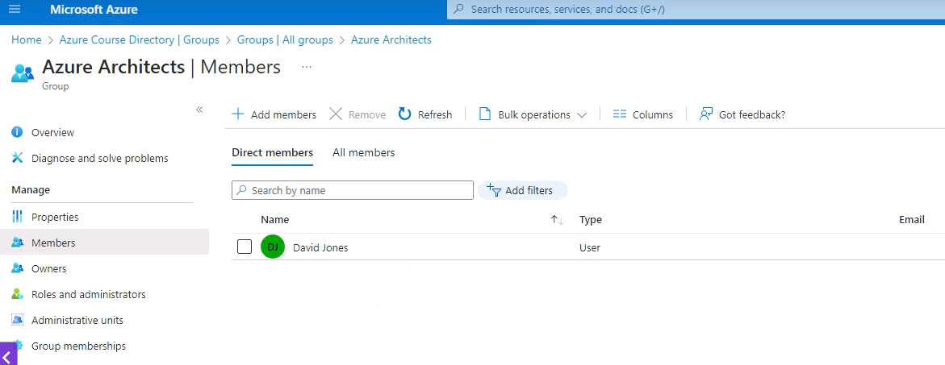

So this is how we work with users and groups in Azure AD.

### Azure AD Licenses

Now, one of the most important aspects of Azure AD is the license model of Azure AD. And that because the licenses of Azure Active Directory have great effect on the functionality and the price of Azure Active Directory, which makes it extremely important to understand the differences between those licenses so that we can recommend the right solution for the right system, and the right customer. So let's take a quick look at the values licenses of Azure Active Directory, and the main differences between them.

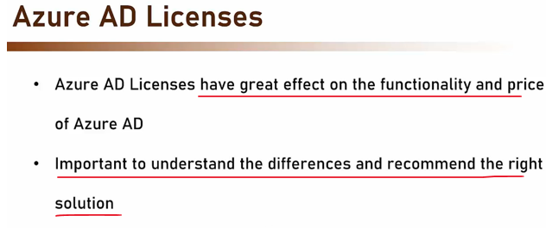

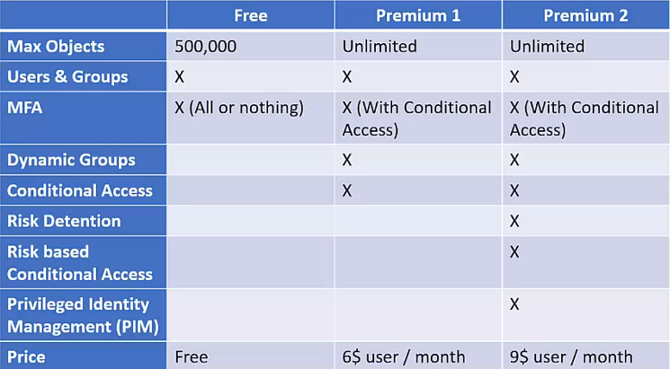

So let's start with free, which is the default license model, and which is also what we have right now in our own tenant. So the free tenant is limited to 500,000 objects, and by objects we mean users and groups. The free license also has limited support for MFA, and we'll talk about MFA in just a minute. And basically that's it. We don't have dynamic groups, or conditional access, and so on. With a premium one license, first we have a price, and the price here is $6 per user per month. And what we get with the premium one license is a better MFA support, and also dynamic groups and conditional access. And then we have the premium two license, which will cost us $9 per user per month, and contains all the features of Azure Active Directory. So when designing the authentication and authorization of your system, make sure to select the right license for your requirements.

### MFA – Multi Factor Authentication

In general, when talking about authentication, we talk about three factors that make the authentication valid. One, is something you know. Such as username and password combination, security question and more. The second is something you have. Such as a phone or smart card. And the third factor, is something you are. Such as fingerprint, iris scan, or other biometric data. You are probably very familiar with the username and password combination factor.

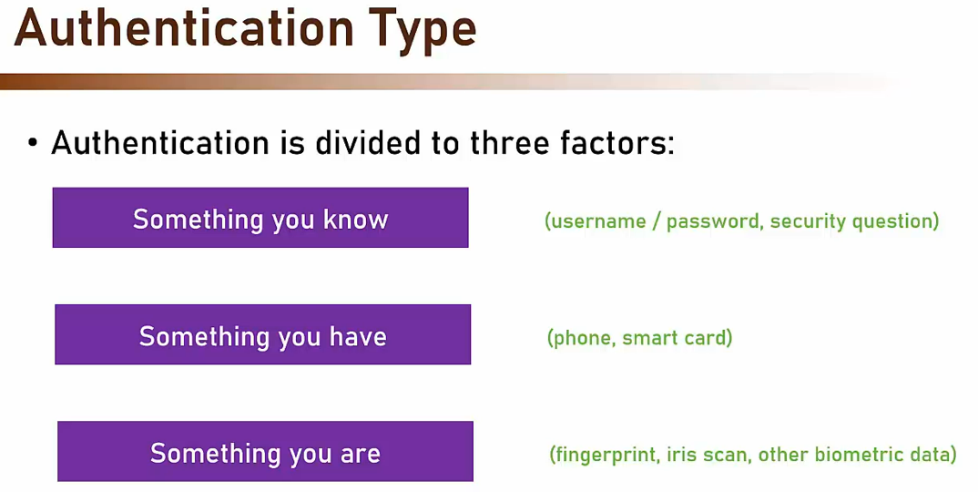

And now you know that it's in fact an implementation of the something you know factor. Now, when designing a new system, we need to pick the right authentication factor for the system. And there are some considerations we need to take into account. First, is feasibility. Can we actually implement this factor? For example, if we go for a fingerprint scan for our website, we need to be aware of the fact that not all computers and phones have a fingerprint scanner. And last consideration, is the ease of use. Username and password combination is usually the easiest factor to use. Besides perhaps fingerprint and face scan. And it's definitely quicker than receiving a text and typing it down. If our intended audience is the general population, including elderly people or others that might have a hard time figuring out complex authentication mechanism, we better go for the easier method. The last thing to consider, is of course the sensitivity of the data, the system holds.

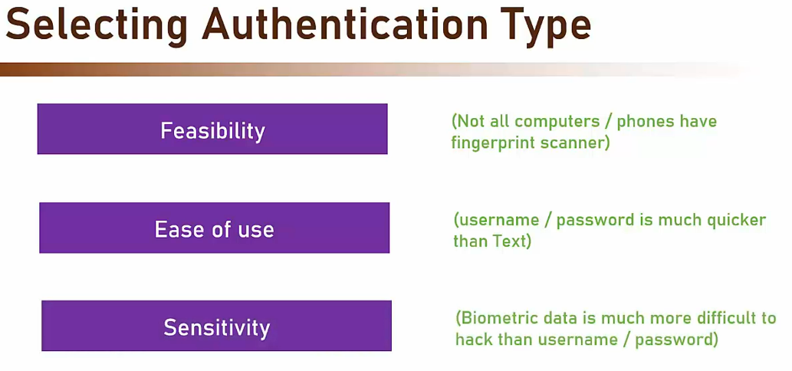

The more sensitive the data, the safer authentication method we will want to use. For example, biometric data is much more difficult to hack than username password combination. So you should always think how sensitive the data you are trying to protect when choosing the authentication type. But, that's not all. For extremely sensitive systems, such as in banking, medical, et cetera. It's sometimes a good idea to go for two-factor authentication. What this means, is that we pick two of the three factors, which are, as you probably remember, something you know, something you have and something you are. And require them for the authentication. For example, and this is perhaps the most common case of two-factor authentication.

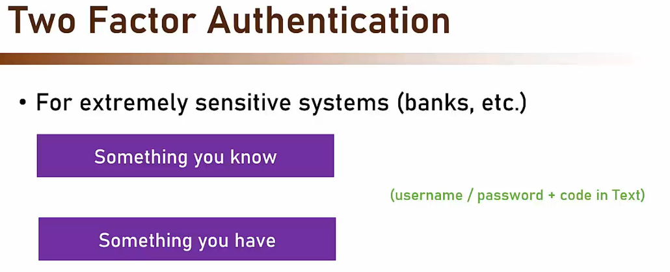

The system might require username and password. And if they were correct, the user will have to type in a code received in a text message. In other words, the system employs two factors. Something you know, and something you have. Other examples include username and password. And also fingerprint scan.

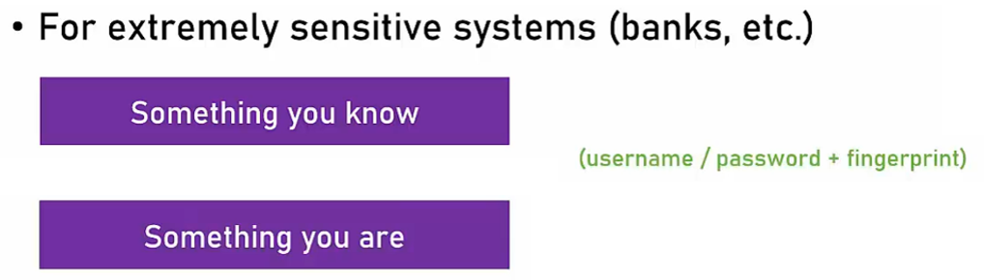

Or text to phone and fingerprint.

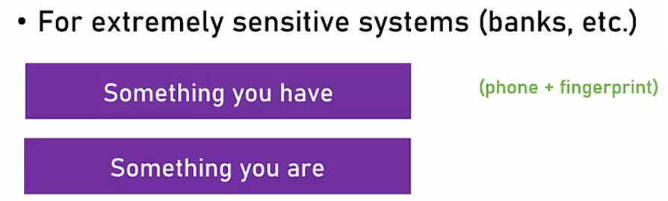

Now to be honest, these combinations are quite rare. And usually what you will see is, either username password and text to the phone. Or a fingerprint scan. And that because hacking fingerprints is much more difficult than the other options. But still it's something that can be implemented. Now I want to go back to the authentication engine selection. When selecting the authentication engine, make sure it supports multiple authentication types. Such as username, password, text, smart code, et cetera. As well as multifactor authentication. You don't want to find yourself someone in the future, when the authentication requirements change, and you cannot follow them with the current authentication engine. In addition, all these capabilities should come out of the box. You shouldn't be required to develop anything in order to have advanced authentication types and multifactor authentication. So this is another factor in selecting the authentication engine.

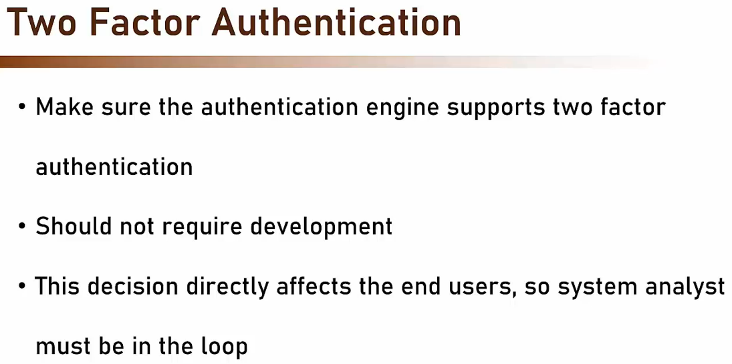

Now, note the decision about whether to use two-factor authentication or even which authentication type to use, is something that will directly affect the end users. So you should always consult with the system analyst before making such decisions.

### Azure AD Security Defaults

One of the nice feature of Azure Active Directory is the security defaults. Using security defaults, we can increase protection of the organization in the Free tier. If you remember when we compared the various license models in Azure AD, we saw that full MFA, or multifactor authentication protection, exists only with P1 and P2 licenses. However, with security defaults, we can increase the protection of the sign-ins, even in the Free tier. And what it does is that it adds pre-configured security settings, such as requiring all users to use multifactor authentication, which blocks 99.9% of account compromises. In addition, it blocks legacy authentication and more. But admittedly, the really interesting part is the MFA, the multifactor authentication. And the nice thing here is that this multifactor authentication comes at no additional cost, which means the Free license is, well, still free.

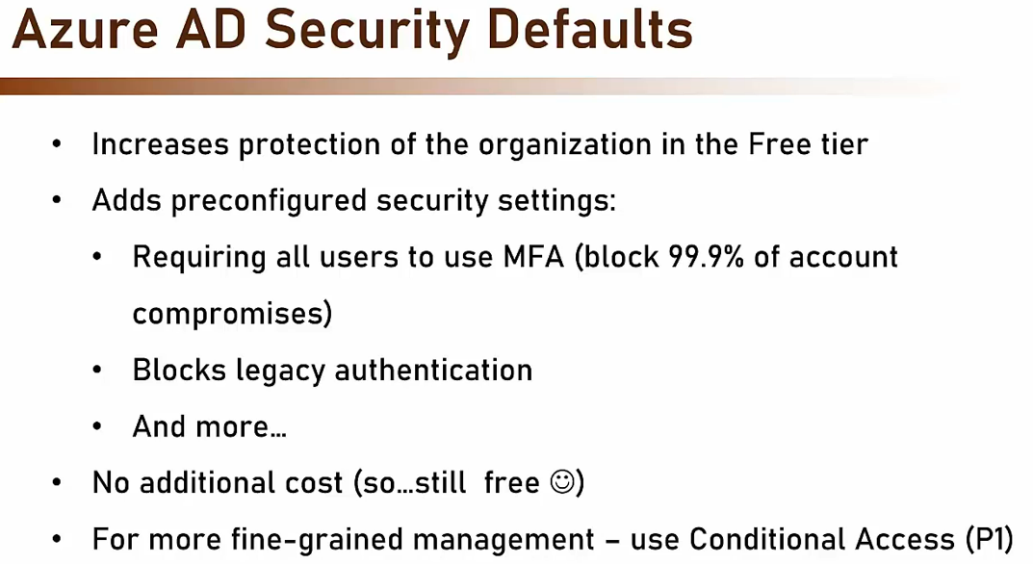

Now, if you need more fine-grained management of the multifactor authentication, then you will have to use the Conditional Access, which is available only from the P1 license and up. The MFA in security defaults is a blanket MFA, so all users will have the multifactor authentication, and you won't be able to decide which user from which location and under which condition will have the MFA enabled.

Using Security Defaults

So, let's see how to work with security defaults. So, let's go again to Entra. And here go to properties right here. And let's scroll down. And here you can see security defaults. Now, by default, our organization is protected by security defaults. And in all tenants that were created after 2019, security defaults are on by default.

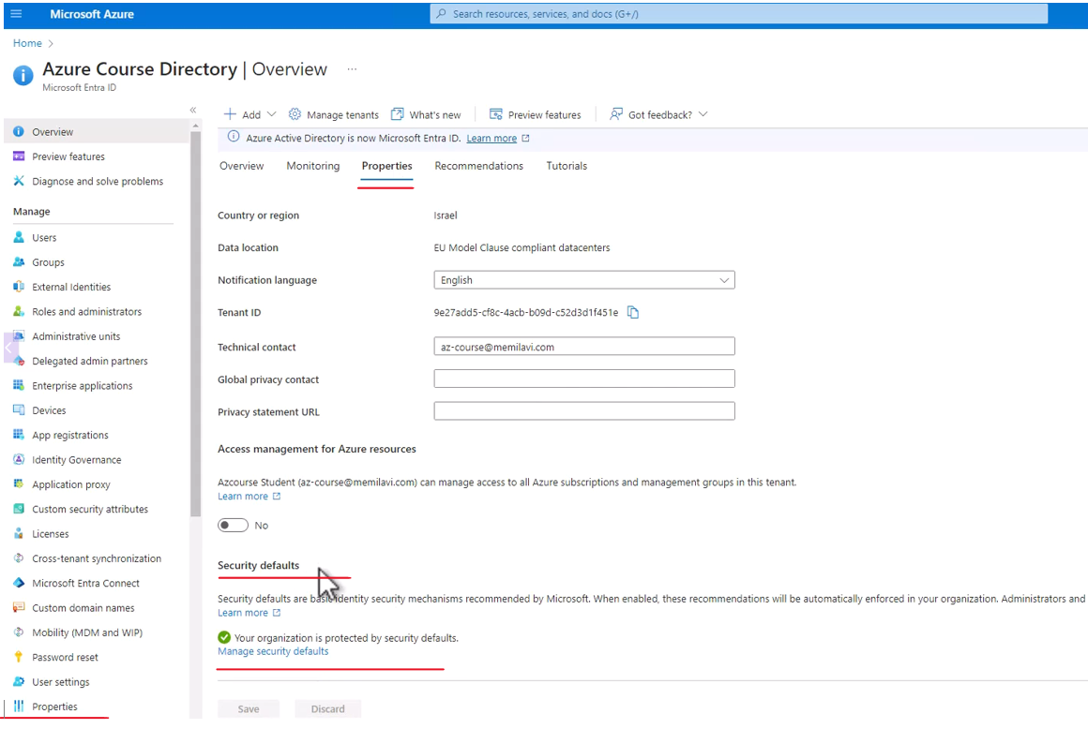

Now, click the manage security defaults. And from here, we can disable security defaults. As you can see, currently it is enabled and we can disable that. And we'll get a warning if you will do that. And actually we are not interested in disabling it. So, let's enable it back and cancel.

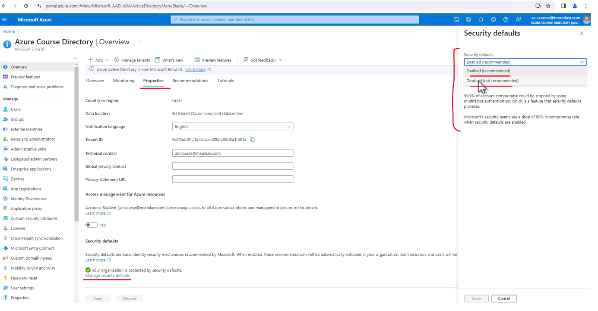

Now, let's see what is the actual effect of using security defaults. So, let's go to users. And let's try to sign in again as the new user that we created before, which is David Jones. So, let's copy the username and open an incognito mode.

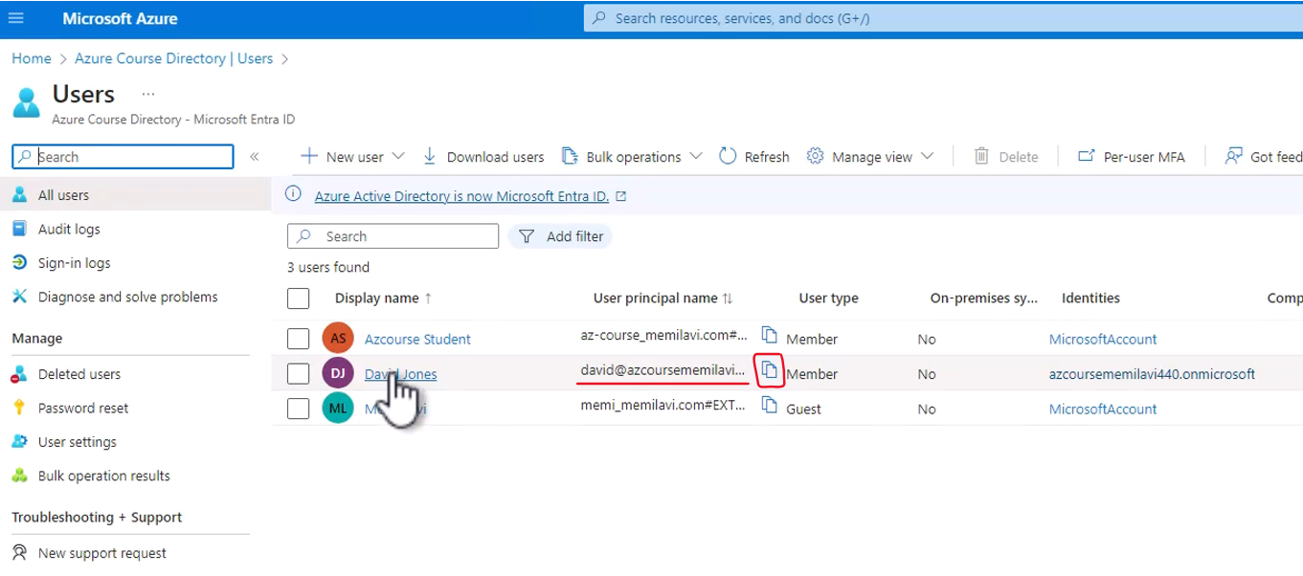

And let's go to the portal and paste here the username of David. And let's type in the password.

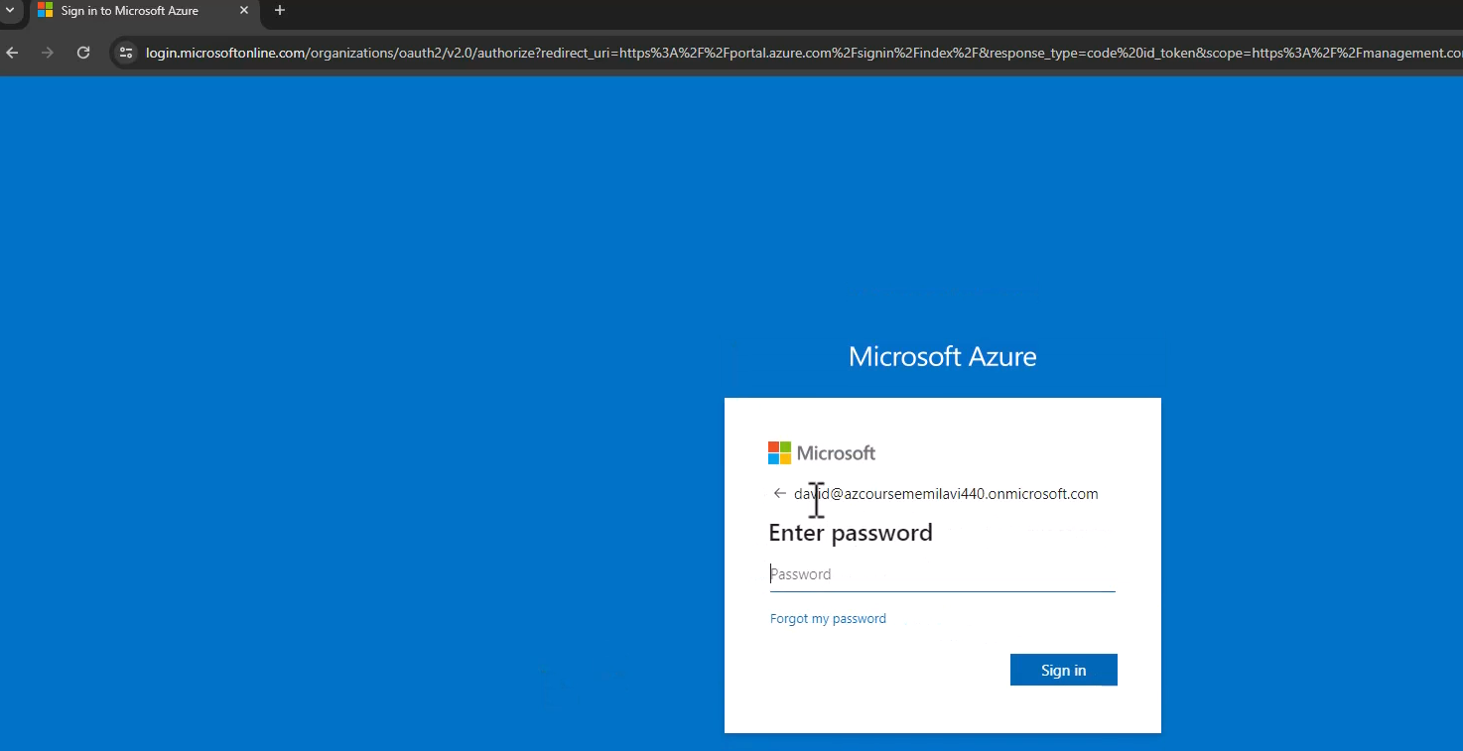

And note this window.

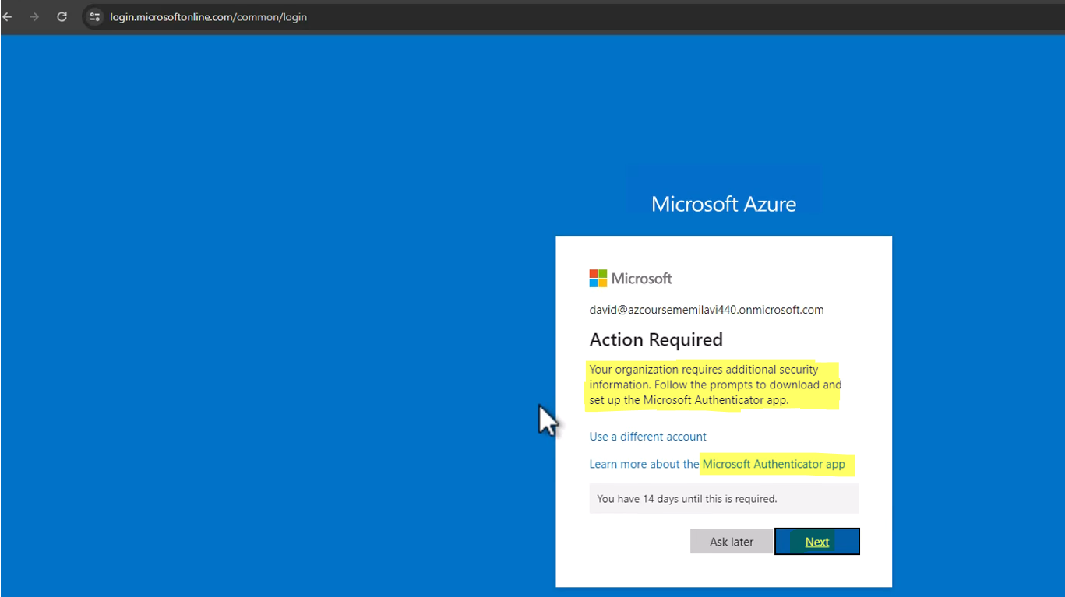

Since we have security defaults on, we are now required to download and set up the Microsoft Authenticator app, which will be used as a multi-factor authentication mechanism for our tenant. Now, I'm not going to actually set it up now, but this is the effect of security defaults. And if we didn't have security defaults, then at this step, I would simply be presented with the portal. So, this is what security defaults does. And as we mentioned, it is highly recommended to leave security defaults enabled to improve the security of our tenant.

### RBAC – Role Based Access Control

|  |  |
| --- | --- |
| The next topic we are going to cover to make it all work together is role-based access control or RBAC. So what exactly is RBAC? To understand it, let's go back in history. In the past, authorization was defined per user or user group.  For example, David is allowed to add items to the inventory, or John is not allowed to read data of other doctors. This type of authorization was very granular and is extremely hard to maintain. Think, for example, what happens when David leaves the company.  The system admin now needs to go through all the authorization definitions of David, which can be dozens, and cancel each and every one of them. Or, for example, what happens when we have a new category in the store and we need to allow all employees to add items to its inventory. | With this kind of authorization, it means we need to go through all users in the system and grant each and every one of them the right to work with the new category. So, as you can see, definitely hard to maintain. |

To solve this problem, RBAC was invented. With RBAC we have three elements that together define the authorizations. We have the Users, we have Roles and we have the Authorizations.

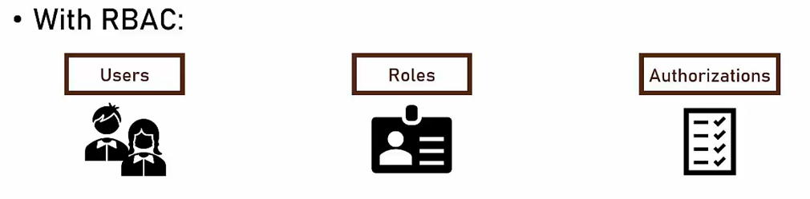

Let's see an example that will explain it. We are now going to define authorization for a hotel system. So let's say we have two users, Jane and David. We also have two roles, Hotel Owner and Front Desk. Note that these roles are real life roles and that they represent actual roles in the hotel. Next, we define three privileges we want to grant. Using these privileges, we allow to set the price of a one night stay, we allow to check in guests and also to check them out.

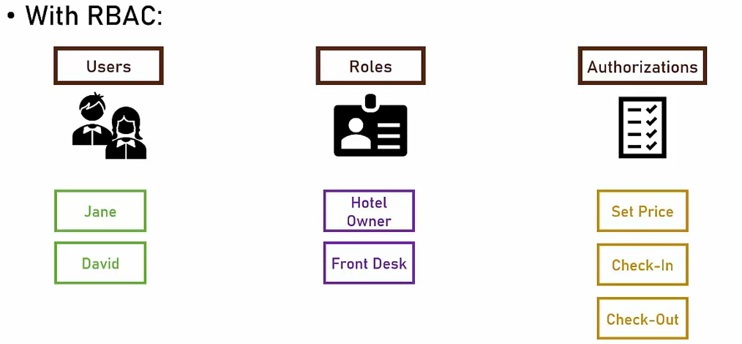

The next thing we do is to associate roles with authorizations.

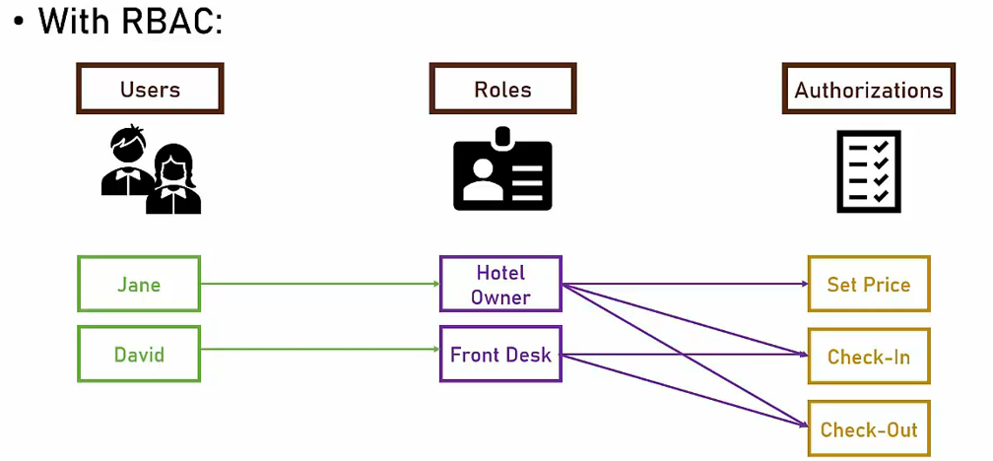

For example, the hotel owner can naturally do everything in the hotel, so he can set the price, check in and check out. The front desk employees, on the other hand, can only check in and check out. Note that they cannot set the price. Note also that up until now, we didn't talk about the actual users, we just associated roles to privileges. The next step is to associate actual users to roles. So in this case, Jane is the hotel owner and David is at the front desk. And that's it. It's that simple. We now have a much simpler system to maintain. The privileges of the roles are more or less constant and are not changed frequently. And the association of users to roles is very simple and is often a one-to-one association. To see how simple it is, let's add another user. So Rachel is a new hotel employee and we now need to add her to our authorization engine. Rachel is going to be a front desk employee, so the only thing we need to do is to add her to the front desk role and that's it. She will be granted automatically all the rights that are granted to the front desk role.

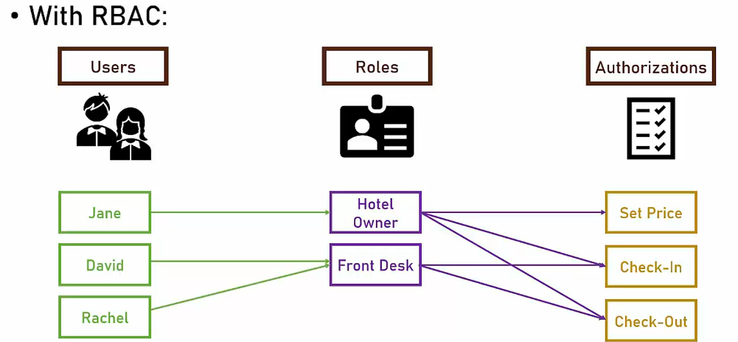

So we talked about RBAC in general and now let's talk about RBAC in Azure. So, in order to perform any operation or access any data in Azure, you have to have the appropriate tool. So, for example, if you want to create resource groups or access data in SQL or see metrics of App Services, then you have to have the right role, because if you don't, then you will get an empty portal. Now, you might be wondering, how you can do all these operations even without any defining any roles.

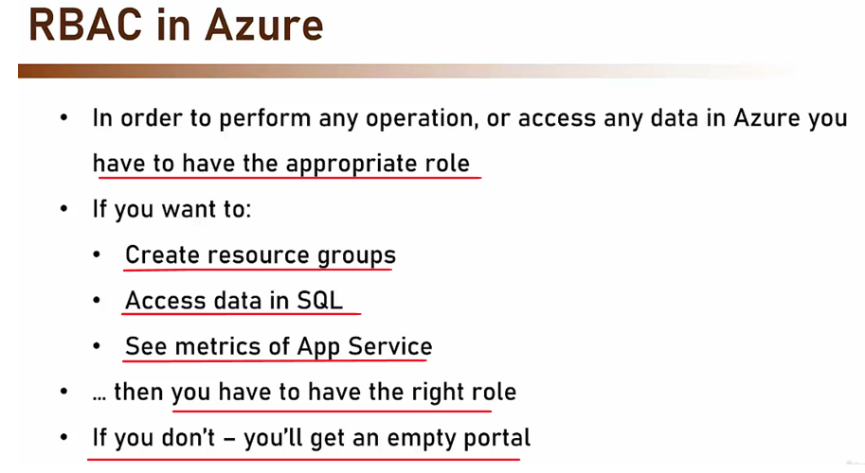

And the reason is that when creating the new subscription, you will automatically granted the highest role available in Azure, which is the owner. But for any other users, you will have to define the roles in Azure. So, in Azure, there are, in general, three types of roles. There is the owner, the contributor, and the reader. Now, the owner can perform any action on the resource including assigning roles to it. So, as an owner, you can add users and groups to resources in Azure, so that they can do various operations on them. The contributor also can perform any action on the resource, but he cannot assign roles to it. And the reader can only view data, but he cannot change anything.

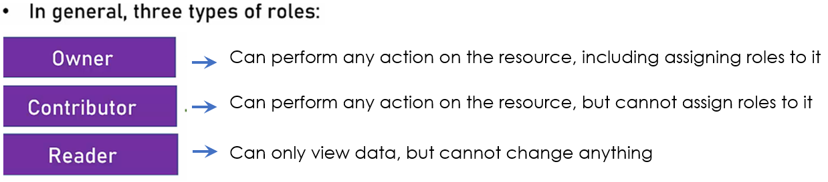

So, let's look at some examples. So, you can see here three roles in Azure.

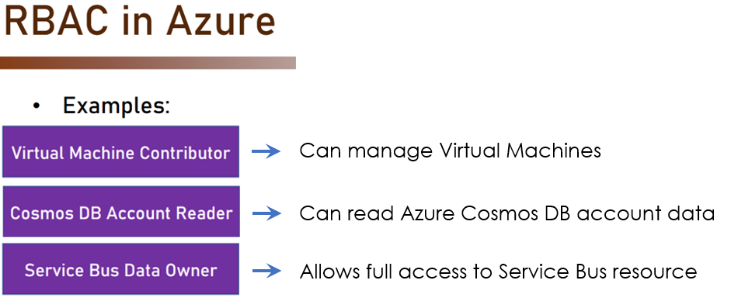

We have the Virtual Machine Contributor, the Cosmos DB Account Reader and the Service Bus Data Owner. So, as you can probably guess, virtual machine contributor can manage virtual machines. Cosmos DB account reader can read Azure Cosmos DB account data but he cannot create or modify existing Cosmos DB accounts. And the service bus data owner allows full access to service bus resources, including assigning new roles, users and groups to this service bus. Now, if you'll go back to the scenario we discussed in the previous lecture, then as you probably remember, we have the users, the roles and the authorizations.

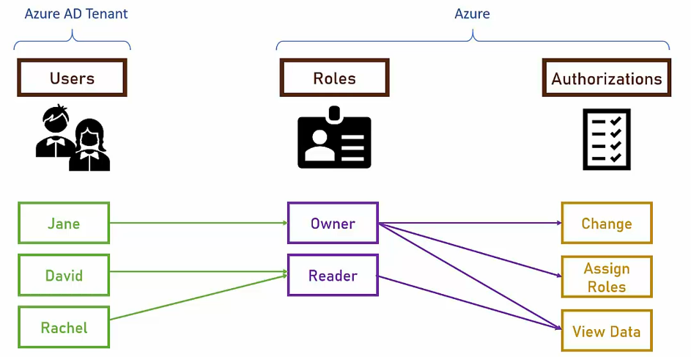

So, how does it looks like in Azure? Well, in Azure, the users are defined in the Azure AD Tenant, but the roles and the authorizations are defined in Azure itself. So, basically, in order to assign roles in Azure, we assign users and groups from the Azure AD Tenant into roles in Azure. Now, note that it's always better to assign roles to groups and not to individual users because it is much easier to maintain it like this. Remember, the granular the assignment, the harder it is to maintain.

* It's always better to assign roles to groups and not individual users
* Easier maintenance

So, as usual, let's go to the Portal. And the first thing I want to do is to create a new resource group, and we will demonstrate on this resource group the work with roles. So, let's do that. Let's go to Resource groups right here. And note that, currently, we have various resource groups right here and we can view them and access them.

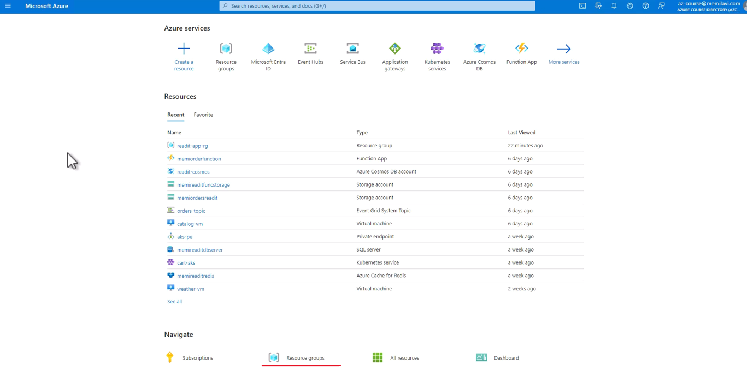

And, of course, this is the resource group that we are usually working with in this course. But, again, I want to create a new one.

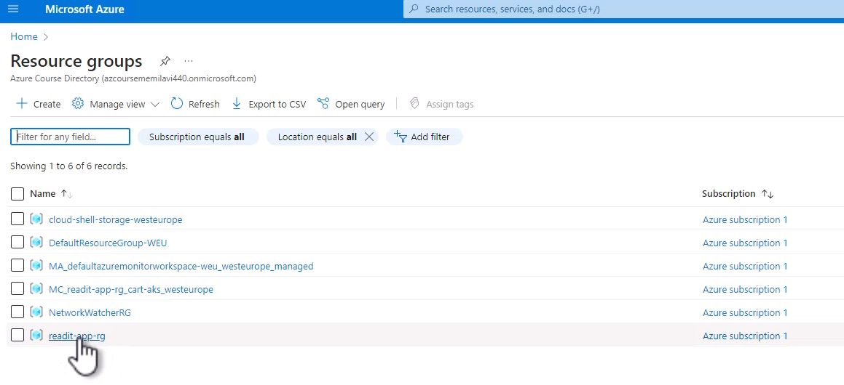

So, click Create. And let's name this resource group test-rg, like that, and select some Region, it doesn't really matter which Region. So, let's Review + create, and Create.

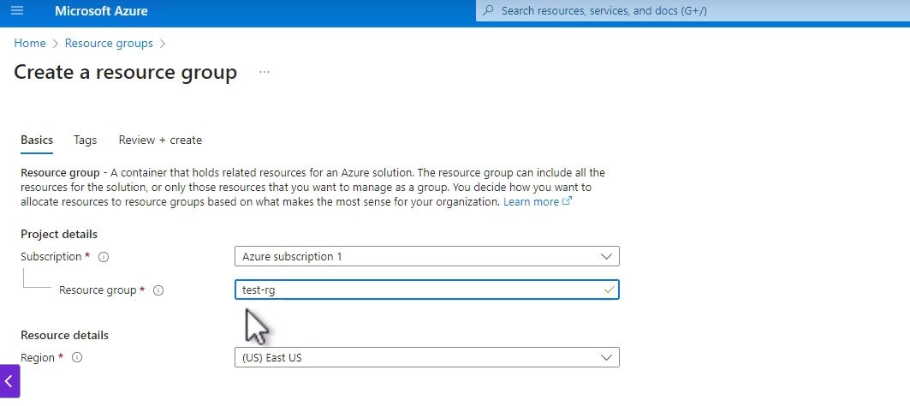

So, let's wait for this resource group to be created. And here it is. So, now, let's go into the new resource group.

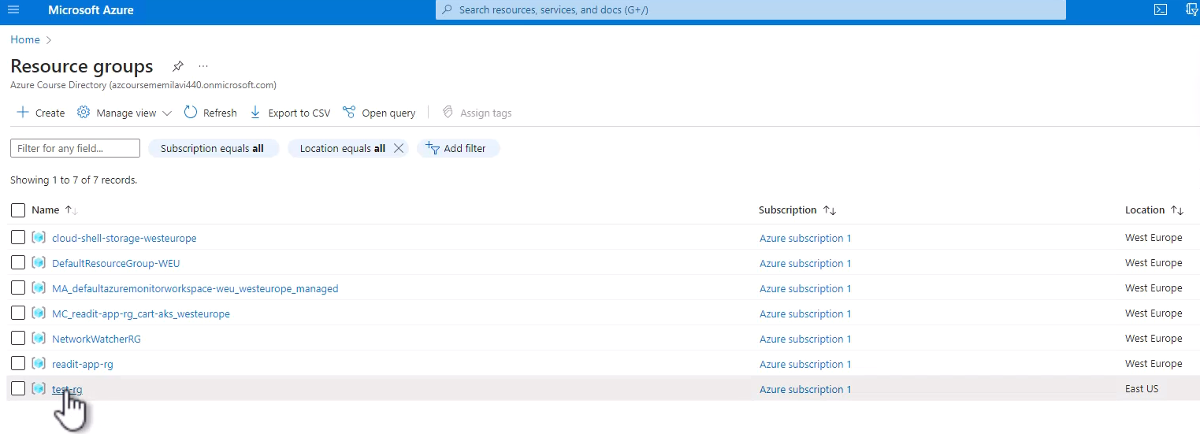

And, in this resource group, I want to go to Access control.

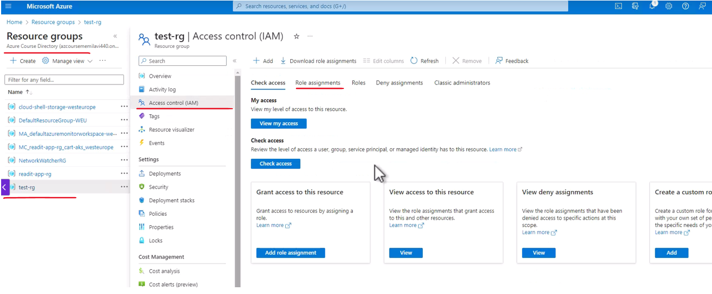

And note that this menu item, Access control, is available in almost all resources in Azure, and this is a place where you assign roles and manage roles in general in the Azure Portal. So, let's go to Access control. And, now, go to the Role assignments tab right here. And note that, currently, there is one user that is assigned a role on this resource group, and this user is basically you.

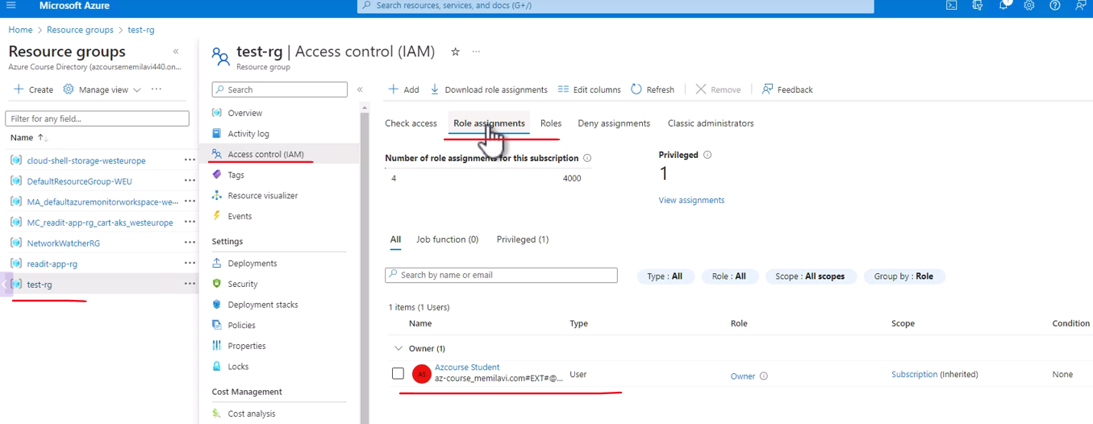

So, in my case, that is the name of the user, yours, of course, will be different. And do note that this user is of the Type of, well, User, and the Role is Owner. And remember that Owner is the most powerful role in Azure, and it basically allows me to do everything in this resource group and also in all the resources inside this resource group. Now, note the Scope column right here. And the Scope of this role is Subscription, meaning, I have the Owner role at this Subscription level. And the reason that I see the role here in the resource group is because this role is inherited from the Subscription. So, I didn't assign myself explicitly a role on this resource group, and, actually, we saw that we didn't do anything special with this resource group, we just created it. But, since we, the owners, of this subscription created this resource group, then we automatically have been assigned an Owner role to this resource group from this Subscription. So, this is how inheritance works with roles.

And, now, let's add role assignment to this resource group. So, click Add, and Add role assignment.

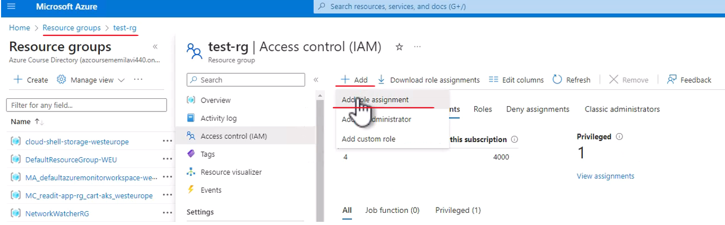

And the first thing we need to do is to select what is the role that we want to assign. And note that we have here two types of roles. We have the Job function roles which are roles that are specific to a service. For example, take a look at this one, the AcrPull. So, as you can guess from its name, this role grants pull permission at the ACR service, or the Azure Container Registry, which we worked with before. Another example is, let's say, this one, API Management Service Contributor. So, this role grants the contributor role at the API Management Service. Again, it doesn't really matter what is a API Management Service, but, as you can guess from the name, this is a specific service.

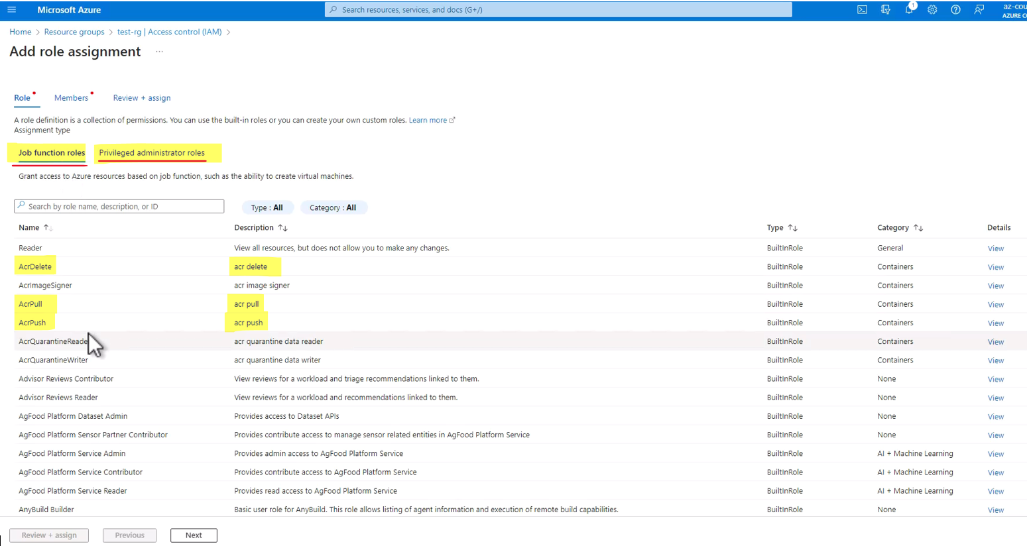

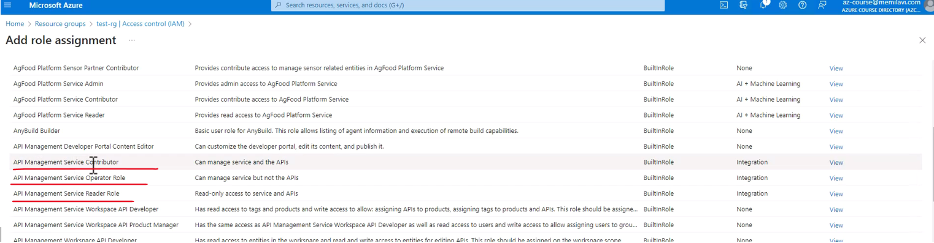

However, I want to go to the second tab, the Privileged Administrator roles, which are roles that are not specific to a service, but are service wide in the subscription. And you will usually want to grant Job function roles to make sure that the given role provides the minimum permissions required, and this is always best practice, but, for our demonstration, I will go with this one.

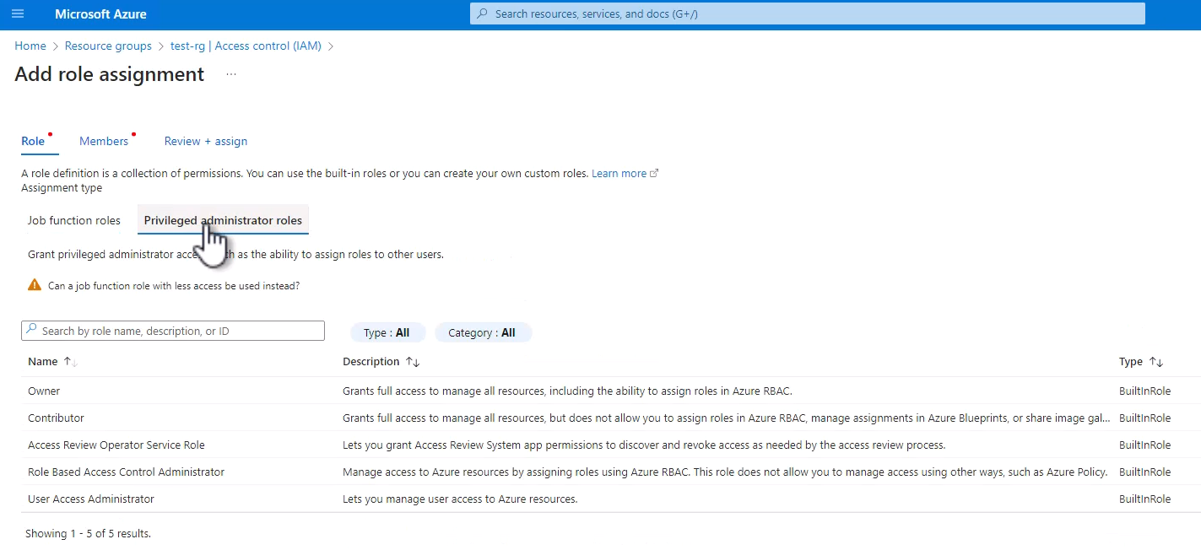

So, I want to assign the contributor role to a group. So, select Contributor, and Next. And, now, we need to select who do we want to assign this role to. And we want to assign it to a user group or service principle.

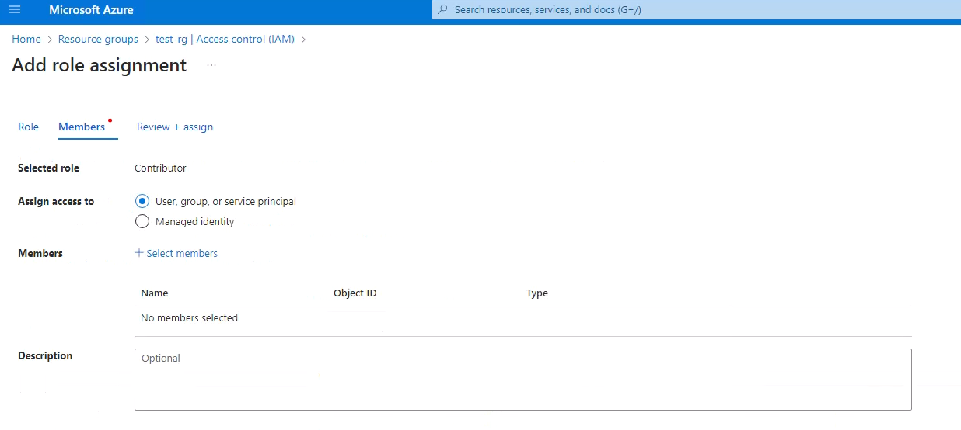

So, make sure this is selected, and click Select members. And here are the users and the groups in our tenant. And look at this group that we created earlier, and we want to grant the contributor role to the Azure Architects group, and, by extension, to all the users inside this group. So, select this group, and Select

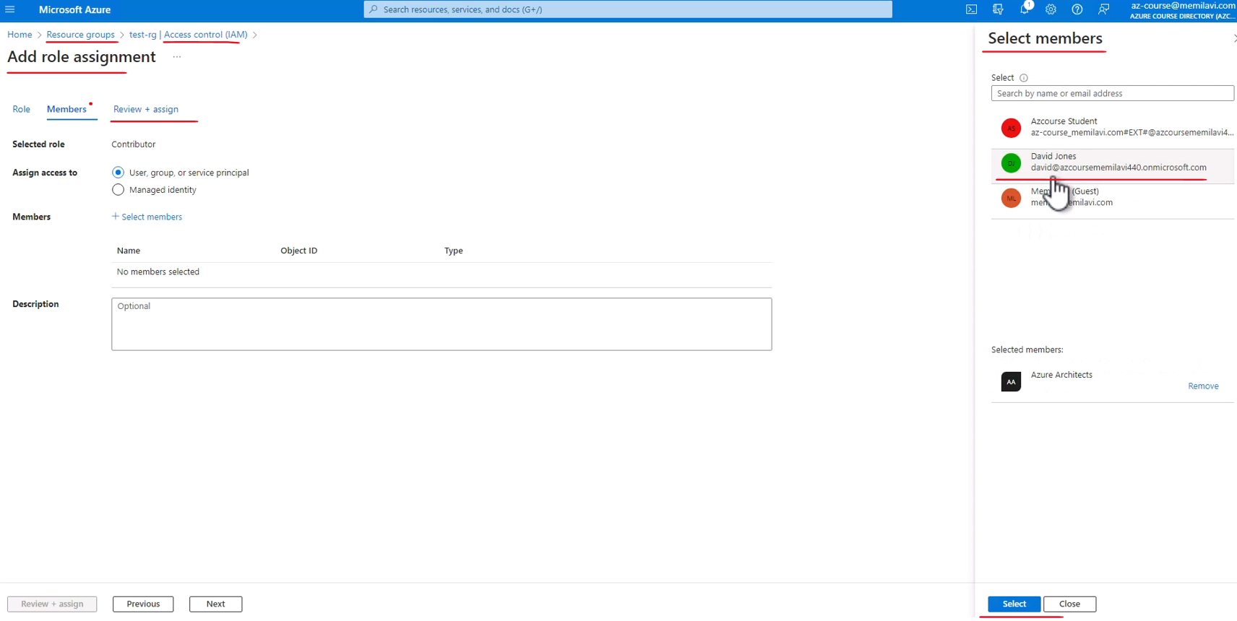

Review + assign, and, again, Review + assign. And, now, the role is being assigned to this resource group, and it was assigned a note that the list now was changed. And in addition to the Owner users that we saw before, we now have a single Contributor, which is the Azure Architects, and this is a Group. So, we can see the Name of the group, the Type of it, the Role that we just assigned, and also note the Scope. And, this time, the Scope is This resource and that is because we assigned the role explicitly to this resource group.

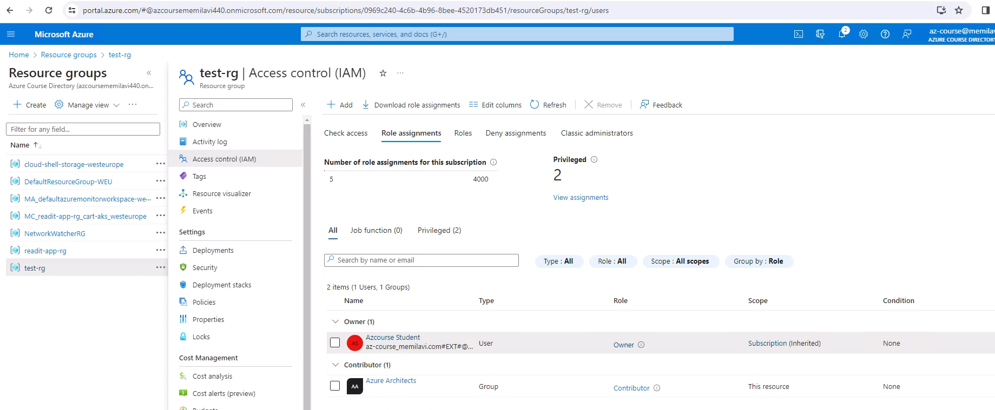

Now, let's see what is the effect of this assignment. And, for that, we are going to sign in as a user in the Azure Architects group. And we are going to do that using our old friend, David Jones. So, let's duplicate this page. And, here, let's go to Entra. And go to Users. And here is David Jones. So, copy his User principal name. And, now, go to Incognito mode, and go, again, to the Portal. And let's sign in as David. So, paste the username here, and now the password. And Ask later. And let's say we don't need to see it again, so, Yes. And here we are in the Portal. Now, if you remember, the last time we signed into the portal as David, we got a message that we don't have any subscription to view in the Portal, and that was because we didn't have any roles or permissions to view any subscription. However, now, it's different. So, here, click Resource groups. And note what we have here. We can close that. Great. Note what we have here. We can see the resource group that we assigned a role for the Azure Architects group. And that is because David is part of this group, of the Azure Architects group.

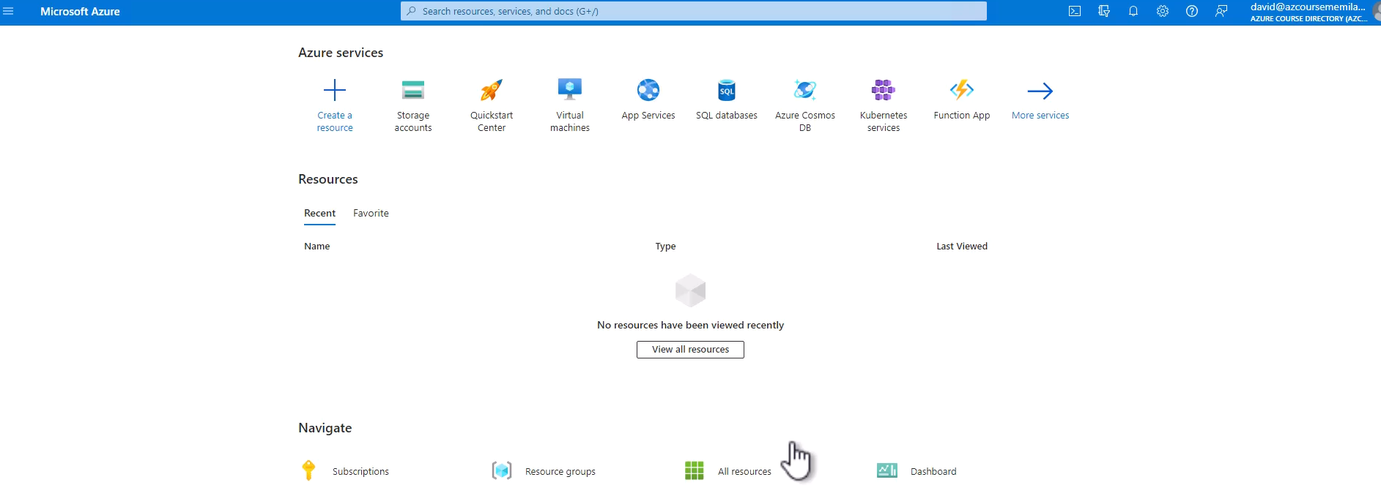

Now, if you remember, when we looked at the list of resource groups as the owner, there were much more resource groups. But, now, we can see only a single one, and that is because we have permissions to view only a single resource group.

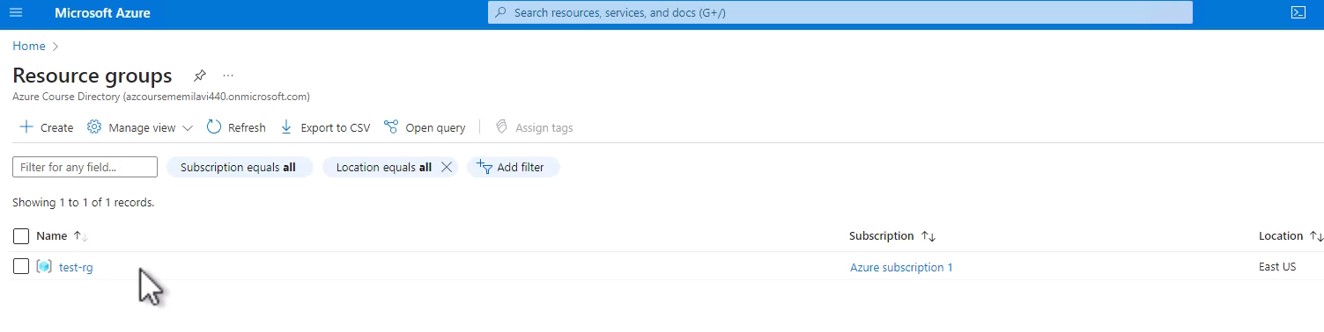

So, let's go into this resource group. And, let's go again to Access control, and let's see whether, as David, we can add role assignments. So, click here, Add. And note that this is disabled. And the reason that it is disabled and we cannot add role assignment is because we are contributors in this resource group.

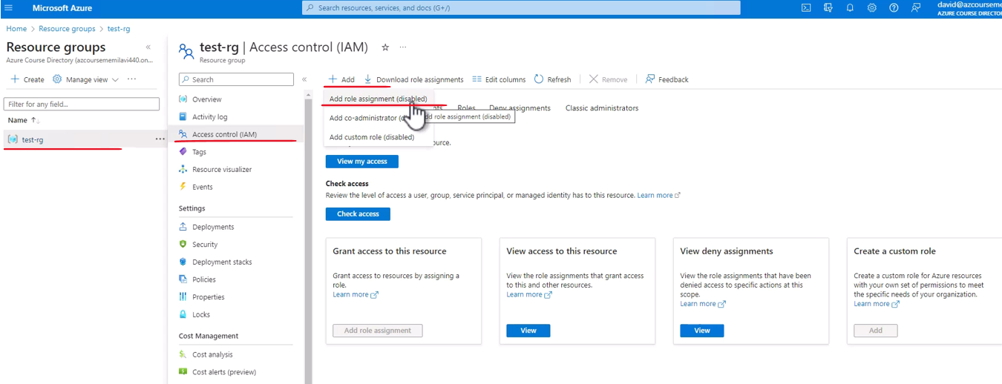

And, as contributors, we cannot manage users for this resource group, only owners can manage users. And, therefore, we cannot add role assignment to this resource group. However, we can create resources. So, let's see how to do that. For example, let's go here and go to Storage account, and let's create a new storage account. So, click Create. And note the resource group here. We cannot place the storage account in any other resource group, since we don't have permissions for that.

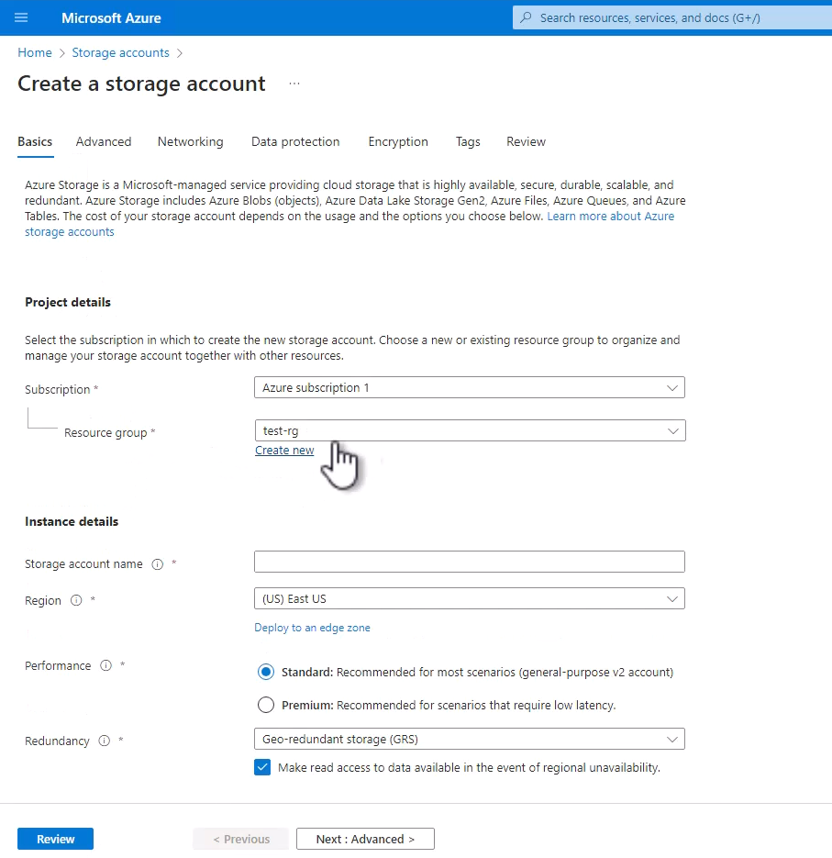

Set the storage account name. So, let's name that roletestmemi. And, again, this name will not be available for you. We don't really care about the region or anything else, we just want to see that we can create the storage account. So, click Review. And let's wait for the validation to complete. And Create. So, let's see whether the storage account will be created. And the storage account was created. So, it seems that, as contributors, we can create resources in the resource group, and we indeed cannot manage users in the resource group.

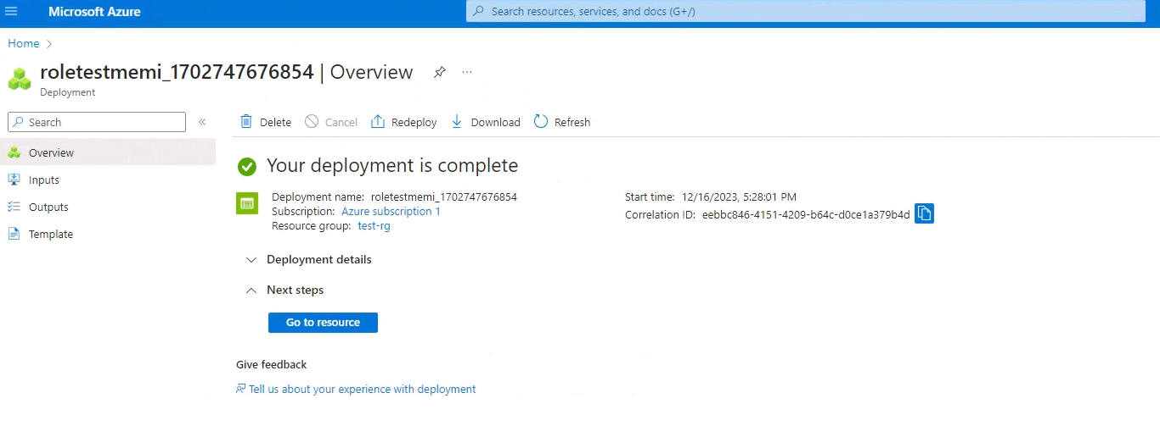

So, this is how we work with roles in Azure. And note that this specific scenario of granting role for a specific resource group is extremely common, because, many times, organizations deploy multiple apps, each in its own resource group, and it's very convenient to grant role for a specific resource group for the, let's say, developers and QA team working on this specific app. And, therefore, you will find yourself quite often granting roles to resource group. So, now, let's close this page. And we don't need the resource group anymore, so we can delete it. So, let's go here to the Overview, and Delete resource group, and copy the name, and paste it here. And Delete, and Delete. Great. So, now, the resource group is being deleted.

### Managed Identities

The next topic I want to discuss is managed identities. Managed identities is the ability to assign Azure AD identity to Azure resource. And that means that this resource can connect to other Azure resources using this identity. And that means that using managed identities, there is no need to handle credentials such as usernames, passwords, et cetera. The identity of the connecting resource is enough to identify the resource and to allow it to access the resource. Now, when talking about managed identities we basically talk about two types of managed identities. The first one is system assigned, which means the identity is managed by Azure, is tied to the resources lifecycle. And that means that when the resource is deleted, so is the identity. The second type is user assigned, and in this case the identity, or the managed identity is managed by the user. And that means that the identity can be assigned to multiple resources and is not tied to any lifecycle. Now, most of the times you are going to use system assigned identity because they are much easier to handle and manage. And this is also what we will do in the demo that we will see in just a few seconds. Now, these are the resources that can be assigned managed identity, or in other words that can have an identity which they can use when connecting to other resources. So, the resources are App Service, Virtual Machine, Event Grid, Function, and more. But basically you will use it on one of these resources. In our demo, we will use it on the app service. In addition, these are the resources that can be authorized using managed identity. And these are SQL, Event Hubs, Service Bus, Storage, Key Vault, and more. So, in our demo, we are going to assign managed identity to the inventory app service and use it to connect to the Azure SQL of the read it website.